Article Type

####-##-##

https://doi.org/placeholderurl

*Type of the Paper (Original Research Article)*

R Programming Estimation of Poultry Residue Biogas Kinetic Parameters

Abdulhalim Musa Abubakar 1, *, Muhammad Jimada Aliyu2, Sulaiman Isah Usman3, Tahiru Saka3, Baudilio Coto4, Simisani Ndaba5, Ahmad Abubakar Mustapha6

1Department of Chemical Engineering, Faculty of Engineering, Modibbo Adama University, PMB 2076, Yola, Adamawa State, Nigeria

2Chemical Engineering Department, School of Infrastructure, Process Engineering and Technology, Federal University of Technology, Minna, Niger State, Nigeria

3Department of Chemical Engineering, Faculty of Engineering, University of Maiduguri, PMB 1069, Bama Road, Maiduguri, Borno State, Nigeria

4Chemical, Energy and Mechanical Technology Department, School of Experimental Sciences and Technology (ESCET), Rey Juan Carlos University, c/ Tulipan s/n, Móstoles, Madrid, 2893, Spain

5Department of Computer Science, University of Botswana, Gaborone, Botswana

6School of Computer Science and Engineering, VIT-AP University, Andhra Pradesh, India

* Correspondence: [abdulhalim@mau.edu.ng](mailto:abdulhalim@mau.edu.ng) (https://orcid.org/0000-0002-1304-3515)

Abstract

For over half a century ago, serious advances have been made as regards biogas production from poultry manure mono-digestion, with lots of identified hinderance solved. Finding biogas kinetic parameters to forecast the cumulative biogas yield (CBY) from several existing model and performing response surface methodology (RSM) optimization on chosen explanatory variables using numerous regression and Design-Expert software tools is not new. Using a bench-scale bioreactor, a fixed CBY-retention time (RT) dataset, an R programming language code to solve nonlinear regression analysis to determine the parameters of some biogas kinetic models return Logistic, modified-Gompertz, First-Order, Cone and Transference model, as the best fitting model, ranking from the best. Experimentally, a 3 days lag phase (LP) and 4748 cm3 maximum biogas yield fits a peak biogas potential, BP = 11934 cm3, production rate, k = 0.0254 and shape factor (SF) of 1.2737 from Logistic model having the highest R2 value = 0.9943, followed by modified-Gompertz, where LP = 2.2 days and BP = 5723 cm3. However, findings show that an R source code for one-factorial RSM optimization, where RT is the covariate variable, puts the predicted quadratic model as the second best in the ranking (R2 = 0.9934 & maximum CBY = 4979 cm3). The program was designed to also give the statistical metrics and the residual and fitted plots associated with the regression and optimization studies. Therefore, R programming capability to forecast kinetic parameters of chicken manure (CM) biogas production have been effectively demonstrated. The need to fill the void still existing as regards the application of computational fluid dynamics (CFD), artificial intelligence and neural network predictive modeling for mono-digested CM should be a thing of concern to wrap up studies on this particular substrate.

**Keywords:**Poultry waste; R programming; Biogas kinetics; Chicken manure; Biogas optimization.

**Citation:**

1. Introduction

Poultry residue utilization for biogas production has gained significant attention in recent years due to its potential to address both environmental and energy challenges (1–9). It also provides a renewable energy source that can contribute to sustainable energy production (10–18). Poultry waste, comprising manure, bedding materials, and feed residuals, is rich in organic matter suitable for anaerobic digestion (AD), a process that converts organic materials into biogas, primarily composed of methane (CH4) and carbon dioxide (CO2). Low C/N ratio (between 3.83:1, 6:1 and 12:1) and higher total ammonia (NH3) compositions of chicken manure (CM) slows down its digestion; hence, its supplementation with carbon and trace elements-rich feedstock is mostly suggested/co-digested (19,20,29–32,21–28). However, the production of biogas using sole CM had been considered economically viable in other studies (33), as it is reported that 1000 kg of chicken litter will produce 200 m3 of biogas (34). This gave rise to the construction of plants or the partial/full utilization of existing ones, such as the Minhe Chicken Manure Biogas Plant in Yantai City, China (35,36), Beijing Deqingyuan Chicken Farm Waste Utilization plant in YanQing District, China (37), N & N Biogas Plant in Singapore (38), 500 L biogas plant in Ramallah City, Palestine (39,40) and the 400 kW capacity Eastern Lithuania biogas plant (41), to take advantage of the feedstock having about 10-30% total solids, 3.2-4.9% total nitrogen, 28% protein, 2.3% fat and 10.2% fiber contents. Thus, CM is almost a breakthrough biogas feedstock discovered, in which inhibitions by NH3 (35,42,51–56,43–50), nitrogen (57–60), pharmaceuticals (61–65), during acetate-to-CH4 conversion (66) and volatile fatty acid contents (67–70), were effectively addressed over the years. As far back as 1970s, ways to mitigate poultry waste pollution via anaerobic biogas production as alternative to natural gas/liquefied petroleum gas and the production of biofertilizer has been given serious attention (71–79). The technique relies on the presence or addition of enzymes (80–83), additives (84–91), biochar (92–100) and several microorganisms (98,101,110–113,102–109) to degrade the manure. For CM, either biogas kinetics or microbial growth kinetics (114–116) of its anaerobic decomposition during biogas generation had been investigated. For example, to optimize biogas production from poultry residue, understanding the kinetics of biogas generation, such as the modified-Gompertz, First-Order, Transference, Logistic and Cone models, is crucial. In those models, kinetic parameters such as the maximum biogas potential (BP), lag phase duration (LP), maximum specific rate constant (k) and shape factor (SF) play pivotal roles in designing and operating efficient biogas plants. However, accurately determining these parameters experimentally can be time-consuming and resource-intensive.

Using MATLAB, a linear model was previously developed for a specific biogas production data from poultry manure (117), as well as the fitting of the modified-Gompertz model to compute the unknown kinetic parameters by Song et al. (2019). Ma et al. (2021) utilized Matlab 2016a to determine the kinetic parameters of the modified-Gompertz model for CM data while Bayrakdar et al. (2018) used Microsoft Excel to do the same. Nonlinear regression was performed to determine the parameters of the First-Order and the modified-Gompertz models using Origin 9.0 by Cai et al. (2021) and Wanqin et al. (2012) for CM AD cumulative biogas/CH4 yield (CBY) data. Moreso, Microsoft Excel 2010 and an undisclosed software were used by Liu et al. (2018) and Liang et al. (2017) to determine the parameters of the modified-Gompertz model via nonlinear regression, respectively. First-Order biogas kinetic parameters were also determined using Statistica 13 (TIBCO) software by Szwarc et al. (2023) through nonlinear regression, as well as an unnamed tool by Mahdy, Song, et al. (2020). A suitable regression tool was used by Qiao, Bi, Yin, et al. (2018) to compute the parameters of the two-stage model, modified-Gompertz and First-Order kinetics and describe the biogas generation from the same biomass. Furthermore, a rarely used software called NLREG 6.6 was employed to estimate the kinetic parameters of the First-Order and the modified First-Order model (125). One fundamental demerit of all these applications is the time spent in guessing the unknown model parameters. Even though the flexibility and efficiency of R programming allow for the utilization of sophisticated models that can simulate and predict biogas production kinetics based on experimental data, it has not been used for that purpose. R programming for nonlinear regression analysis have been applied in many different fields of study (126), but is gradually becoming useful in chemical engineering (e.g., Hill & Michaelis-Menten model enzyme kinetics and in membrane separation technology) (127). This study aims to leverage R programming for the estimation of kinetic parameters associated with the AD of poultry residue. Here, the relationship between measured CBY response variable and an explanatory variable, in this case, retention time (RT) is well established in order to draw inferences on the unknown parameters, which have some physical interpretation, as stated by Peddada & Haseman (2005). The present study came close to the application of R regression function to connect the cumulative biochemical oxygen demand with incubation time, studied earlier by Ruckstuhl (2016). The R function ‘**nls’** is used for estimating parameters via nonlinear least squares (129,130), such as the biogas kinetic models.

The knowledge gained from this research can inform the design and optimization of AD systems tailored specifically for poultry waste recycle/reuse, thereby enhancing biogas production efficiency and sustainability. Previously, Marchioro et al. (2018) used a suitable optimization software where they looked at the effect of feed ratios and recirculation time of free NH3 concentration, biogas and CH4 yield; Cai et al. (2021) examined the influence of pH, total ammonia nitrogen and temperature on CM CH4 yield using Design-Expert 12.00.0; Karichappan et al. (2014) run a Box-Behnken design to checkmate the effect of time, alkalinity dose, pH and temperature on biogas yield from chicken processing industry wastewater in Stat Ease Design Expert 8.0.7.1; Design Expert V7.0 was employed by Chun et al. (2015) on biogas yield response taken agitation velocity and reaction time as factors; employing reaction time and ultrasound amplitude as independent variables, Braeutigam et al. (2014) sought to optimize biogas yield and CH4 content from CM fermentation data in Design Expert V8; in a study by Al-Zoubi et al. (2024), pH, C/N ratio and RT were optimized via Minitab for biogas yield maximization; CH4 production was optimized by Abouelenien et al. (2021) by taking incubation time, inoculum ratio, sodium chloride (NaCl) concentration and total solid (TS) content as independent variable, using Design Expert 7 and; lastly, Waziri et al. (2023) utilized time, pH, temperature, substrate and biomass concentrations as featured variables in the optimization of CBY from CM using Stat-Ease 360 user defined design. The primary goal of this research is to investigate how RT influences the yield of biogas. The specific goals are to generate biogas from poultry wastes and quantify the volume of biogas produced using the weight determination method. Ngaram et al. (2016) have used the water displacement method in their study, disadvantaged by the inability to recover the gas produced. Gas chromatograph (26,118,120,138) can be used to quantitatively or qualitatively measure the amount of biogas produced even when the amount is < 0.45 dm3 in which a portable biogas analyzer/flow meter can begin to detect (41,139,140). In the present work, an appropriate biogas measurement via weight determination technique is easier compared to gas measurement by manometer and volume computation using Boyle and Gay-Lussac laws (141,142). France, Spain and Poland in Europe (143) and Egypt, Nigeria and South Africa in Africa lead the chart as the largest chicken producers, boosting an enormous biogas potential. An optimized biogas production and utilization from CM will reduced the cost of natural gas and preserve the natural balance (144). In addition, BP from previous studies on poultry waste were contrasted with the study herein and the similarities, research gaps and future focus areas were detailed. A comprehensive R program capable of application for one-factorial Response Surface Methodology (RSM) optimization of biogas yield taking RT as factor was generated and the predicted polynomial model was compared with the selected kinetic model.

2.Materials and Methods

2.1. Biogas Production Steps

The biogas generation system used comprises of a digesting tank with a maximum capacity of 21200 cm³, constructed from 1 mm thick mild steel and enveloped by 3 polythene bags to enhance heat absorption for effective gas generation. The vessel possesses an internal diameter of 30 cm, an external diameter of 32 cm and a height of 30 cm. Additionally, the digester features a ½-inch galvanized pipe with a plug for slurry and sludge outlet. Substrate/feedstock, which is poultry waste in this case, was introduced through a 5.5 cm inlet, before manual mixing of the substrate with water was kick-started. This is shown in Figure 1.



**Figure 1:** AutoCAD 3D Model of the CM Biodigester

The vessel was linked to a gas collector tube exposed to sunlight in an open-setting for a maximum of 30 days. Before channeling the poultry waste in to the tank, it underwent a 3-day sun-drying to eliminate moisture. Subsequently, the dried waste was crushed into loose particles using mortar and pestle to enhance surface area. Furthermore, a screening process was employed to eliminate foreign materials like sawdust, feathers, pebbles and animal feed from the poultry waste. Hydrothermal, hyper-thermophilic hydrolysis, thermal, microwave, physical, chemical, biological, thermochemical, leaching, air-stripping, CO2 injection, pressure swing conditioning, enzymatic, ultrasonic radiation, aerobic and combined pretreatment methods (122,140,153–157,145–152) may enhance CH4/biogas yield in addition to mere drying of the poultry waste. Purposely, Pm 4800 model: 9387 digital weighing balance was used to measure 4kg of poultry manure and thoroughly mixed with 1378 cm³ of water (2.9:1 ratio), before transferring it into the biodigester through the feed inlet hole. The biodigester was then connected to the gas holder tube. The mixture in the biodigester was allowed to ferment at room temperature (between 29-35). As fermentation occur, the displaced base drained through the outlet unit in the gas holder tube. The volume of the base displaced was considered equivalent to the volume of gas produced. Measurements of this volume were taken every 72-h using a measuring cylinder until there was no gas yield for 2 consecutive days. CBY was then determined by adding the current volume measured to the next period successively up to the last day.

2.2. Comparison with Previous Findings

Published manuscripts from 1970-2024 were assessed from Google Scholar record and used to support the study. In those articles, research gaps, advances and areas of future interest were identified.

2.3. Biogas Kinetic Model Fitting

After obtaining the volume of gas generated at intervals of time, the CBY was calculated. Five biogas kinetic models, shown in Table 1, were fitted to empirical CBY data to estimate their respective kinetic parameters in order to ascertain whether it satisfy the predicted dependent variables in the models.

**Table 1:** Biogas Model Parameter

| **Model** | **Equation** | **Parameter** |
| --- | --- | --- |
| Modified-Gompertz |  | BP, k, LP |
| Cone |  | BP, k, LP |
| Logistic |  | BP, k, SF |
| First-Order |  | BP, k |
| Transference |  | BP, k, LP |

where, BP = maximum biogas potential (cm3), LP = lag phase (day), SF = shape factor (dimensionless) and k = maximum specific rate constant (cm3/day).

2.4. R Nonlinear Regression Source Code

R programming software package was downloaded and installed as described by Abubakar et al. (2023) and Kamel & Abonazel (2023). In this program, ‘**#**’ sign was used as descriptive heading for the task the code is designed execute and does not affect the program running or convergence. The CBY-t data of CM obtained was initially specified, followed by a syntax to define the CBY model function, its domain and parameters. R was made to also compute the CBY-predicted values and store them in its memory, which can then be used subsequently for fitting the actual CBY data. A maximum iteration of 100 was specified in each model source code and a room for the user to enter the lower, upper bound parameter values and their initial guess values was allowed. Note that the lower and upper bound values were set as 0 and infinity (Inf), respectively, by default and may be left unchanged by the user. This code uses the **nlsLM** function from the **minpack.lm** package for nonlinear least squares fitting (129,160,161). It is advisable to have the **minpack.lm** package installed before running the code (**install.packages("minpack.lm")**).

Normally, a "singular gradient" error typically occurs when the optimization algorithm used by **nls()** fails to converge to a solution. This could be due to various reasons, such as inappropriate starting/initial values, numerical instabilities, or the chosen model not being suitable for the data, which means it is not invertible. Where such occurred, the initial guess values were changed repeatedly until convergence was achieved. Few statistical metrics formula such as the coefficient of determination (R2), adjusted R2, root mean square error (RMSE), mean absolute percentage error (MAPE), reduced Chi-square and residual sum of squares (RSS), were appropriately entered to calculate them, using their respective expressions obtained from Ryan (2003) and Archontoulis & Miguez (2015). Percentiles versus Regular Residual, Counts versus Regular Residual, Regular Residual versus Independent Variable and Regular Residual versus Predicted CBY are desirable statistical plots from nonlinear regression. Using the right syntax, the R program code was carefully written to produce those plots. At this juncture, the estimated unknown parameters are given in-between the line of code requesting them as outputs, together with the plots in a separate window. In case of non-convergence, a situation prompting the change of certain parameter values or codes, users must have the entire code saved in a notebook file first and adjust any error from it before copying and pasting them back in the R window for the re-run.

2.5. Coding the Correlated Plots

Immediately a successful convergence gave the desired parameters, residual plots and all the statistical parameter estimates, a new line of codes was pasted to produce the Predicted CBY versus Actual CBY plot based on the CM biogas empirical data. It must not be forgotten that this study synonymously refers to CM as poultry manure, as mostly regarded in majority of studies. It is principally the manures from the most commonly recognized poultry animals such as chicken, duck, turkey (163,164), goose, quail, pheasant, guinea fowl, emu, ostrich and partridge. Interested researchers may desire to optimize biogas production from other poultry waste apart from CM using this code, by first running a kinetic study. In this work, the correlated plot generated using the R program was stored in Appendix A while Origin software was used to build a finer replicate plot.

2.6. R Program form RSM Optimization

To execute an RSM optimization in R, the ‘**rsm**’ package was loaded and installed before running the optimization. The ‘**rsm**’ library contains function for RSM and regression modelling. An “**1m**” function that fits a quadratic regression model to the actual biogas data was used. The formula  specifies that the response variable **CBY** is regressed on **t** (linear term) and **t^2** (quadratic term). The data argument specifies the data frame containing the variables. Additional line of code that print the fitted model equation and its coefficients was included. The  function converts the fitted model object into a formula, and  returns the coefficients of the fitted model. A line of codes that generates a scatter plot of actual versus predicted values was written. Basically, the  function calculates the predicted values based on the fitted model. Then, the  function creates the scatter plot, where  represents the actual values and  represents the predicted values. The red line represents perfect prediction (actual = predicted). Finally, a line of code: “” that is a summary of the fitted model, including information such as coefficients, standard errors, t-values, and R2 value, among others, was written to complete the coding. R was instigated to give 4 residual plots as a result of the predicted model developed.

3. Results and Discussion

3.1. Biogas Yield from CM and Research Trend

Based on the gas volume data provided in Table 2, it is evident that the feed slurry containing 4kg of poultry waste yielded a higher quantity of biogas, likely due to its elevated volatile solid content.

**Table 2:** Daily and CBY of Biogas from Poultry Manure

| **Incubation Period, t (day)** | **Daily Yield (cm3/4kg)** | **CBY (cm3/4kg)** |
| --- | --- | --- |
| 0 | 0 | 0 |
| 1 | 0 | 0 |
| 3 | 490 | 490 |
| 6 | 615 | 1105 |
| 9 | 514 | 1619 |
| 12 | 462 | 2081 |
| 15 | 486 | 2567 |
| 18 | 524 | 3091 |
| 21 | 680 | 3771 |
| 24 | 648 | 4419 |
| 27 | 240 | 4659 |
| 30 | 89.0 | 4748 |

Biogas production commenced 3 days after introducing the slurries into the digester. This delayed onset is associated with the presence of oxygen in the manure mixture, requiring an initial aerobic period for oxygen-loving bacteria to deplete any traces before the actual digestion process. The fluctuating rate of biogas generation may be influenced by variations in bacterial population during different growth phases and external factors like temperature fluctuations. The substantial biogas yield of up to 4748 cm3 from poultry droppings is attributed to their rich organic carbon and organic matter content, possibly linked to the fowls' diet. Neupane (2018) reported the possible realization of 3 m3/day of biogas from 50 kg of poultry faeces, which is far less than the rate achieved in this study (158.27 cm3/day) from 4 kg of CM. Wahidah et al. (2022) who reported 2.04 m3 of biogas from 20 kg of CM, as well as several literature outputs reported in Table 3, clearly show that biogas yield from the animal residue is largely dependent on the anaerobic reacting conditions specified. It also impossible to fix a generic optimal condition for biogas production from poultry manure, as did Johari et al. (2023). AD of poultry waste (Table 3) occurred at 4-65 psychrophilic-mesophilic-thermophilic temperature, some of which is explained vividly in Yin et al. (2018) and Liang et al. (2017), 6.7-9.5 pH, 18-254 days retention time (RT) and at varying manure feed volume. Thus, several researchers adopted the mesophilic region (25-40) for CM digestion, in which Shapovalov et al. (2019) and Salyuk et al. (2014) assert that moisture content is more likely to affect the stability of the process compared to a thermophilic mode (50-60) of biogas production (170,171).

**Table 3:** Biogas/Methane Yield from Poultry Waste Single Feedstock

| **Feed** | **Operating Conditions** | **Yield** | **Author(s)** |
| --- | --- | --- | --- |
| 750g powdered poultry litter | 20 L plastic digester at 25; RT = 4 weeks | 5.04-16.3 cm3 | (117) |
| 1.9-4.7 g VS/L day | Semi continuous mode two-stage anaerobic system; 12 days HRT | 554 mL/g VSfeed | (32) |
| 80, 120 & 180 gVS/L | 30 L small-sized batch bioreactor at 35; RT = 45 days; zeolite additive | 70% | (90) |
| NR | 10 L glass fermenter; mesophilic temp | 31 kg | (116) |
| 0.5-3 g oDM/L day (28.5, 57, 114 & 171 g/day) | 15 L anaerobic fermenter (CSTR); 38; 60 days HRT; 20 rpm stirring speed | 2.73-5.67 L | (172) |
| 42 kg/day waste + 84 L water | 10 m3 GGC-2047 model fix dome bio-digester; 65 days RT | 3000 L | (18) |
| 10.14 g VS/L | 2 L reactor; 38 mesophilic temp.; 35 days fermentation time | 362.5 m3 | (140) |
| 293.3 g | 21-Chamber bio-fermenter; 36-41; 2 dm3 input capacity; 60 days | 340 m3/t | (173) |
| CM with 11.2% TS, 8.27% VS and CHNOS of 35.2, 4.83, 5.44, 30.1 & 0.84% dry | 12 L mesophilic CSTR; 400 days reactor operating time; 35; 200-300 rpm agitation; 30 days HRT | 0.34-0.5 L/gVS | (55) |
| 3 kg litter | 37 mesophilic temp.; 30 days RT | 183 LN biogas/ kg VSadd | (131) |
| 15g | 10 L lab-scale CSTR; 25-39 mesophilic temp.; 7.5-8.5 pH; 3-7 g/L total ammonia nitrogen level | 356.841 mL/g CH4 | (119) |
| 3.14 kg VS/ (L.day) OLR | 2500 m3 working volume full scale plant; 35 mesophilic temp.; 40 days incubation period; 15 min mixing interval; 500 mL batch experiment reactor volume | 508 mL CH4/ gVSadd | (41) |
| 100 mL CM bed volume consisting of 0.8g zeolite/ gVS of CM | 3.2 & 2.56 L LBR-CSTR 2-stage system working volume; 38 mesophilic temp. | 0.36 NLbiogas/ g VSadded | (174) |
| 1:6 poultry manure wastewater mixing ratio | 250 mL conical flask; 25 temperature; 30 days HRT; 2-4 days reaction time; 110-130 rpm agitation | 4.45 mL/g COD | (133) |
| 10 g VS/L (150 mL) | 300 mL serum bottles; 37 temperature; pH = 7; 120 rpm rotation speed | 183 mL CH4/g VSremoved | (120) |
| 4.5 kg oDM/ (m3 day) | 500 m3 fermentation tank; 39 temperature | 188 m3.Mg-1 | (139) |
| NR | 25-40 days RT | 64 mL/g VS | (175) |
| 100g | 2 L bench-scale digester configuration; pH = 6.95-8.86; 38 controlled temperature; 37 days | 785 mL | (176) |
| 10g | 20 L tight lid plastic bucket; 50 days batch mode RT; 35 mesophilic temp. | 73.3 NmL/gVS | (177) |
| 2.8 kg feed + 3.7 L warm water | 60 L cylindrical digester tank; 18 days RT; 6.7-7.4 pH; 28-33.3 digestion temp. | 1300 cm3 | (178) |
| 8.5 kg/day | 4 m3 fix dome bio-digester; 28 days RT; 25-38 temp.; pH = 8-9.5 | 3.25-3.75 m3 | (165) |
| 20g substrate | 50 mL plastic reactor; 160 days batch operation; 35 mesophilic and 50 thermophilic temp. | 331 mL/g TS | (168) |
| 20g substrate | 60 mL syringe; 50 temp. | 121-382 mL/g VS | (169,179,180) |
| 2.5, 3.8 & 5g TS/ (L.day) | Semi-CSTR; 55 thermophilic temp.; 20 days HRT; pH of 6.9-8.3; 267 days reactor operation | 49.8-267.2 mL/g TSin | (181) |
| 4.4 L/kg | 125 mL anaerobic serum vial; 254 days acclimation period; 37 mesophilic temp. | 31 mL/g VS CH4 gas | (182) |
| CM with 29.36 %TS, 21.15 %VS & 8.35 C/N ratio | 10 L reactor with 8 L working volume; 50 rpm agitation; 0.3-0.45 mm biochar particle additive; 15-65 temp.; 30 days course | 0.44 L CH4 | (121) |
| 1-2.5 g/L day | 15 L working volume CSTR; 60 rpm constant stirring rate; 50 days fermentation | 1-13 dm3 | (183) |
| 2.2-3.9 g VS L-1 day-1 | 10 L reaction volume semi CSTR; 77 days HRT | 620 mLN g-1 VS-1 | (54) |
| 18 kg CM (2.5-6 kg TVS/m3 day) | 0.5 m3 pilot-scale digester; ambient temp. | 39.95 m3 biogas & 25.57 m3 CH4 | (184) |
| 2.97-28.85 kg COD/m3/day | 4 L UASB reactor; 35 constant temp.; 10.04-16.45 h | 0.39-9.83 m3/m3/day biogas | (76) |
| 8.04g VS of fresh waste | 250 mL digestion bottles; 4-35 temp.; 32-day period; frequent agitation | 1.65 mL/g VS/day CH4 | (185) |
| 270 L/kg VS | 1 L flask; 40 days acclimation; pH = 7; 50 temp. | 4.5 L/L day biogas & 3.2 L/L day CH4 | (186) |
| 2 kg wet manure at 4-6% TS | 5 L Quickfit glassware & 10 L percolating packed bed digester; 30-35; 14.2 and 29.2 day RT | 0.41-0.44 m3/kg VS added | (187) |
| 10 kg COD/m3 | 3.5 m3 pilot system; fermentation at ambient temp. | 3.57 m3/m3 | (188) |
| 5.9% TS average influent | 587 m3 liquid capacity digester; 35 constant temp.; 22-24 days HRT | 0.38 m3/kg VS added | (189) |
| 30 kg wet droppings + 45 L water | 5 L lab-scale digester; 35 days RT; 25-30 room temp. | 0.54 m3/kg TS | (74) |
| 36.7g wet | 250 mL (200 mL working volume) serum bottles; 37 controlled temp.; 79 days experiment | 561.86-616.99 N mL/g VS | (26) |
| 20g aqueous CM mixture | 300 mL cylindrical glass reactor; 550 thermal treatment; 38 temp.; 1-2 min reaction time; 110 rpm stirring speed; 63-125 m amplitude | 278-393 NL/kg oDM & 65.6-69.3% CH4 | (134) |
| 1g seed sludge | 3 L volume anaerobic biodigester; pH of 7; 40 temp.; 16% alkalinity dose; 21 days’ time | 905 mL | (132) |
| 18 kg/day (110 L) manure production | 0.5 m3 continuous feed biogas plant; 28 days HRT; 6-8 pH; 25-45 temp. | 108 L/day | (40) |
| 37.48% fresh matter chicken droppings | 15 dm3 working capacity glass fermentation BTP-2 reactor; 50 days fermentation; 60 rpm mean speed; 39 mesophilic temp. | 70 m3/Mg CH4 & 121.4 m3/Mg biogas | (190) |
| 100 g/L | 30 L bioreactor; 66 days experiment; 35-37 mesophilic temp. | 7.8 L/d/kg VS | (191) |
| 6 g VS/L/day | 10 L working volume lab-scale CSTR; 52 days HRT; 38 temp. | 2.2-2.4 L/L day (338.3-418.7 mL/g VSadded | (192) |
| Filled to ½ the reactor volume | 2.5 L single-stage and 1 L acidogenic & 5 L methanogenic (two-stage) CSTR reactors; 37 & 53 mesophilic temp.; 80-90 rpm mixing; 16, 12 & 8 days HRT | 459-551 mL/g VS | (193) |
| 3kg out of 5kg collected | 20 L manually agitated & 3.3 L forced circulation substrate system biodigester; 60 days RT; 15 min agitation at 2 h intervals; room temp. & 36 controlled temp. | 0.143 & 0.283 m3/kg VTS | (141) |
| 9 g VS/ L day | 2.5 L semi-CSTR; 20 rpm mixing; 37 days RT; 35, 55 & 70 temp. | 0.199 L/g VSadded | (60) |
| 1300 & 1500g | 4.5 L lab-scale LBR; 36 temp.; 75 days experiment; 4-5 times recirculation/day | 0.272 m3/kg VS CH4 | (118) |
| 0.5-2.5 kg VS/m3/day | 16 L (14.5 L working volume) lab-scale CSTR; 36 mesophilic operation; 268 days digester operation; 23-30 days HRT | 0.28-0.36 m3/kg VS CH4 | (194) |
| 450g | 8 L anaerobic CSTR; 35 constant temp.; 60 rpm continuous stirring speed; 30 days HRT; 6.6-7.6 pH | 0.912 & 0.9197 L/g VSremoval | (195) |
| 1-7.6 kg VS/m3/day | 0.03 m3 working volume pilot scale AnMBR; 37 temp. | 0.59 m3/kg VS | (196) |
| 40% VS dry CM | 250 L semi-continuous bioreactor; 35 mesophilic temp.; 45-90 days experiment | 39.7% biogas & 33.5% CH4 | (197) |
| 1.4 L raw poultry manure + 3.6 L tap water | 20 L airtight container; 0.5 cm sieve manure sizer; 37 mesophilic environment; 35 days production process | 56.38 L/kg | (149) |
| 0.71 VS/TS ratio of chicken litter | 50 mL reaction volume; 29 days RT; 37 temp. | 523 L/kg VS biogas & 240.7 L CH4/kg VS | (82) |
| 10%TS, 7%VS & 104 g/L TCOD CM | 70 mL (120 mL working) total reactor volume of sealed glass serum; 37 mesophilic condition; 90 days operation | 190-340 L kg/VSadded CH4 | (123) |
| 169.3 mL/g VS | 125 mL anaerobic serum vials; 45 days incubation time; 10% TS content; 1:2.5 inoculum ratio; 0 NaCl supplementation | 324.36 mL/g VS CH4 | (136) |
| 51.8 g VS/L | 10 L CSTR; 35 mesophilic mode | 294 mL/g VSmanure CH4 | (100) |
| 40g | 2000 mL (1000 mL working volume) reactor; 22-52 temp.; 20 day RT; 10:1 & 40:1 C/N ratio | 285 mL/g VS | (135) |
| 4 kg | 21200 cm³ digesting tank; 30 days RT; ambient temperature | 4748 cm3 | This study |

*NR – Not reported; VS: Volatile solids; TS: Total solids; VTS: Volatile total solids; oDM: Organic dry matter content; OLR: Organic loading rate; HRT: Hydraulic retention time; CHNOS: Carbon, Hydrogen, Nitrogen, Oxygen & Sulphur; COD: Chemical oxygen demand; TCOD: Total COD; LBR: Leach bed reactor;* AnMBR: Anaerobic membrane bioreactor; UASB: Upflow anaerobic sludge blanket *and; CSTR: Continuous stirred tank reactor.*

Shapovalov et al. (2020) and Bayrakdar et al. (2017) declared that dry fermentation of CM is possible, but an effective route towards achieving that have not been investigated. For large-scale biogas implementation from poultry droppings, it is recommended to obtain the procedural and effective steps developed by Jensen & Ostergaard (2017). In that case, wet fermentation in this study and those frequently reported in the literature (25-41 – Table 3) in the mesophilic temperature regime had been conducted while dry fermentation occurring at both mesophilic and thermophilic temperatures remains a possible breakthrough subject on poultry waste in the future. At the moment, only mesophilic dry fermentation was previously studied for CH4 production from CM (182), as well as thermophilic CH4 and biogas production (181,200–202), with no mention of the use of either dry or wet fermentation approach. A specified temperature of any regime can be regulated using solar system (40,203). Biogas production can also be carried out using semi-solid poultry manure (204). It is obvious that CSTR systems used in Srichat et al. (2013), Liu et al. (2012) and Niu et al. (2015), are less considered for this particular feedstock as revealed by Table 3; and stirring/mixing effect as used in the current study, is usually ignored. The scant is extended to implementing a large scale or pilot plant CM biogas (184,188,189,196,208). There are few reports on fixed-film reactor, two-stage digestion, downflow anaerobic filter/packed bed reactors, anaerobic hybrid reactor (AHR), intermediate membrane contactor, attached-film bioreactor, expanded granular sludge bed reactor (EGSB), temperature-phased anaerobic digestion (TPAD), anaerobic rotating biological reactor, self-mixed anaerobic digester (SMAD), semi-continuous bioreactor, up-flow anaerobic filter (UAF), anaerobic leaching bed reactors (LBRs), plug flow reactors/continuous tubular reactors (CTR), anaerobic sequencing bioreactor (ASBR), AnMBRs, fixed-dome biogas reactor, covered lagoon reactor, polydimethylsiloxane membrane contactor, closed loop anaerobic membrane system (CLAMBS) and UASB reactor configurations utilization for poultry waste biogas manufacture (53,70,213–216,76,153,196,197,209–212). Arriagada et al. (2019) realized that it is possible to efficiently produce biogas from CM at lower RT or HRT often reported in the literature (e.g., 30 days – this study).

Currently, only Reyes et al. (2021) mentions the possibility of applying computational fluid dynamics (CFD) to the analysis biogas production from CM leachate. Specific areas that may be of interest in subsequent studies could be: the simulation of the flow patterns and distribution of the CM biomass within an anaerobic digester to understand how the fluid dynamics affect the mixing and residence time of the substrate within the digester; the analysis of heat transfer processes within biogas digesters, which is crucial for maintaining optimal operating temperatures for the microbial activity responsible for biogas production and hence foster the effective design of a heating systems, thereby ensuring consistent temperature distribution throughout the digester; the modeling of the transport and mixing of gases within the digester, including the movement of biogas, CO2, and other gases produced during the AD process in order to optimize gas collection systems, ensuring efficient capture and removal of biogas for further processing or use; the design and optimization of biogas storage systems, such as gas holders or storage tanks by modeling gas flow dynamics and pressure distribution to ensure the safe and efficient storage of biogas produced from CM and; the assessment of the dispersion of odorous gases and optimizing ventilation systems to minimize odor emissions and maintain acceptable air quality standards. The potential of zeolite and biochar from CM to remove CO2 from biogas had been described previously by Wuri et al. (2018). Removal of hydrogen sulphide (H2S) is also necessary in biogas upgrading (219).

3.2. Biogas Model Parameter Estimate

3.2.1. Nonlinear Regression R Source Code

The R source code in Figure 2 is the painstakingly-written syntax to run a nonlinear regression analysis for the modified-Gompertz, Cone, Logistic, First-Order and Transference model for the CM data in Table 2.

|  |
| --- |

**Figure 2:** Nonlinear Regression Analysis R Program for Modified Gompertz Model

|  |
| --- |

**Figure 3:** Nonlinear Regression Analysis R Program for Cone Model

|  |
| --- |

**Figure 4:** Nonlinear Regression Analysis R Program for Logistic Model

|  |
| --- |

**Figure 5:** Nonlinear Regression Analysis R Program for First-Order Model

|  |
| --- |

**Figure 6:** Nonlinear Regression Analysis R Program for Transference Model

Users must not forget to invoke the package called **minpack.lm** from Load Packages … under the Packages menu in the R V4.3.3. software. Figure 7 showcased the R line of code displayed after selecting the package, **minpack.lm**. After that, the pasted code will now give the computed parameters if the right starting guess were entered.



**Figure 7:** The **minpack.lm** Package under the **nlsLM** Function in R

Ideally, the “<” and “+” symbols found at the beginning of each line of code are not part of the coding. During practical application of this coding, users must note that no line of code should be broken into 2 lines as did in Figure 2-6. Especially, those lines of code beginning with the words “” and “”.

3.2.2. Correlated Plots

Correlating the CBY-RT observed data with the selected biogas kinetic models are necessary for optimization purpose. Modified-Gompertz model in Figure 8a is valuable in biogas production systems as it accurately predicts the cumulative biogas yield over time, considering both lag and decline phases, aiding in optimizing process parameters for enhanced biogas production efficiency. The Cone model in Figure 8b is significant for its ability to characterize substrate utilization kinetics in AD processes, guiding the rate-limiting steps and aiding in designing and operating biogas plants for optimal performance and substrate management. Logistic model line fitted to the experimental CBY values in Figure 8c, is essential for predicting the growth dynamics of microbial populations involved in biogas production, facilitating the assessment of microbial activity and substrate utilization rates, thus guiding process optimization and efficiency improvement efforts.

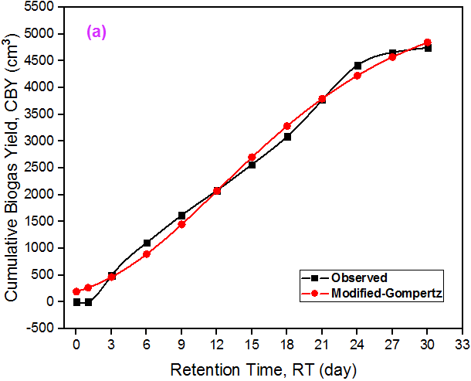 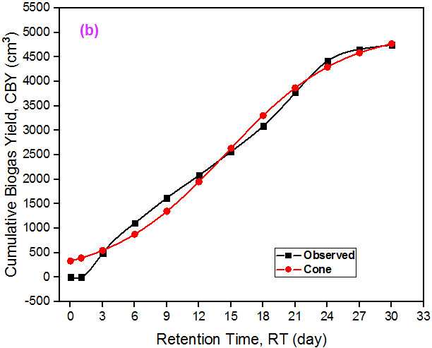

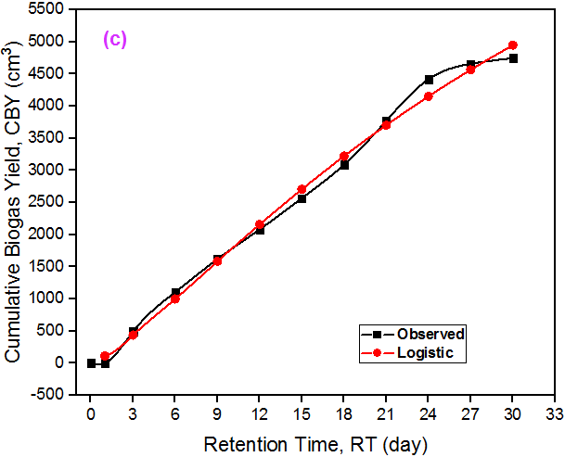 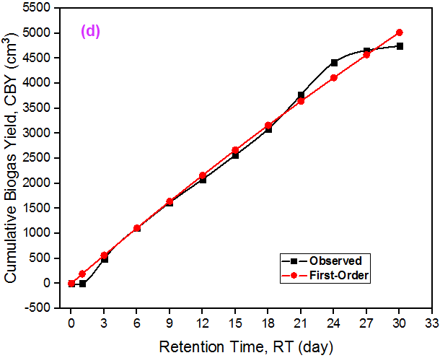

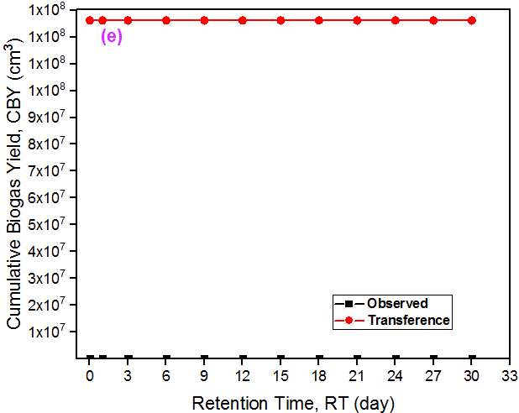 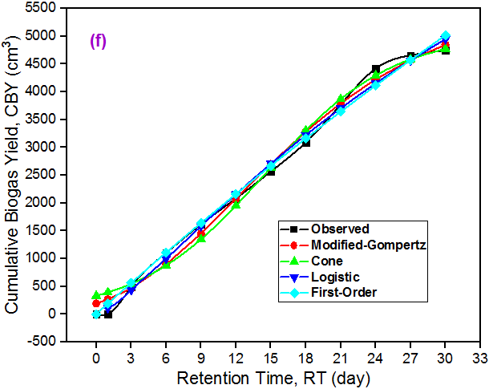

**Figure 8:** Measured CBY versus Predicted CBY for (a-e) Models and (f) Multiple Correlations

In Figure 8d, First-order kinetics play a crucial role in modeling the decomposition of organic matter in AD of the CM, allowing for the estimation of degradation rates and providing a fundamental framework for optimizing RTs and substrate loading rates in biogas systems. Lastly, the Transference model (Figure 8e) is significant in biogas kinetics as it elucidates the mass transfer mechanisms governing substrate conversion, aiding in understanding substrate transport phenomena within anaerobic digesters and optimizing reactor design and operation for improved biogas production from CM. A close fit to the observed CBY in the first 4 models, as observed in Figures 8 (a-d) or Figure 3f, implied agreement of the CM digestion and biogas production rate with the assumptions and given property/definitions of the models. Figure 3f show that, as the observed CBY increases with RT, the predicted CBY through Transference regression analysis decreases linearly with RT – indicating lack of fit. It is observed in Table 4 that the CBY predicted by this model is an average of 126191527.8 cm3 far beyond the reasonable empirical result obtained as well as those predicted by modified-Gompertz, Cone, Logistic and the First-Order kinetics.

**Table 4:** Predicted CBY Values for the Selected Models

|  |  | **Modified-Gompertz** | **Cone** | **Logistic** | **First-Order** | **Transference** |
| --- | --- | --- | --- | --- | --- | --- |
| **t** | **CBY (Expt.)** | **CBY (Prdct.)** | **CBY (Prdct.)** | **CBY (Prdct.)** | **CBY (Prdct.)** | **CBY (Prdct.)** |
| 0 | 0 | 190.6850608 | 330.5322587 | - | 0.00 | 126192685.1 |
| 1 | 0 | 264.1421865 | 391.786572 | 110.11324 | 188.56 | 126192601.4 |
| 3 | 490 | 462.9202206 | 546.2888202 | 434.00389 | 560.94 | 126192434.1 |
| 6 | 1105 | 891.784946 | 876.7392944 | 997.89591 | 1107.81 | 126192183.1 |
| 9 | 1619 | 1447.993085 | 1347.330746 | 1583.0454 | 1640.97 | 126191932.2 |
| 12 | 2081 | 2071.976197 | 1952.446485 | 2157.0208 | 2160.77 | 126191681.2 |
| 15 | 2567 | 2700.390964 | 2636.04858 | 2705.3521 | 2667.54 | 126191430.2 |
| 18 | 3091 | 3284.521838 | 3304.009936 | 3221.6358 | 3161.60 | 126191179.2 |
| 21 | 3771 | 3796.143603 | 3870.283753 | 3703.6518 | 3643.27 | 126190928.2 |
| 24 | 4419 | 4224.93536 | 4295.363927 | 4151.4478 | 4112.87 | 126190677.2 |
| 27 | 4659 | 4572.764488 | 4586.213234 | 4566.2947 | 4570.69 | 126190426.3 |
| 30 | 4748 | 4848.180599 | 4772.820663 | 4950.0876 | 5017.04 | 126190175.3 |

Table 4 was generated by substituting the estimated parameters from the source code run outputs of Figures 2-6, which resulted in the fittings shown in Figure 8. Figure 8f is the correlated plot version given by Origin software, which is similar to the one shown in Appendix A, generated by running a short R source code.

3.2.3. Biogas Kinetic Parameters of CM

R was made to print few statistical measurements for each model used, as shown in Table 5. Varying values of ‘k’ can be attributed to the differences in model structure and assumption.

**Table 5:** Estimated Statistical and Model Parameters

| **Model** | **Parameters** | **R2** | **Adj. R2** | **RMSE** | **RSS** |
| --- | --- | --- | --- | --- | --- |
| Modified-Gompertz | 5722.589  212.0028  2.22663 | 0.9915487 | 0.9883795 | 156.1678 | 292660.5 |
| Cone | 5053.791  231.2949  3.60279 | 0.9858631 | 0.9805618 | 201.9794 | 489547.9 |
| Logistic | 11934.13  0.0254396  1.273715 | 0.9943526 | 0.9922348 | 127.6598 | 195564.3 |
| First-Order | 22374.37  0.008463374 | 0.9927014 | 0.9910794 | 145.1281 | 252746.1 |
| Transference | 1912357043  171.5812  0 | 0.990733 | 0.9872579 | 163.531 | 320908.5 |

*Note: BP (cm3), k (cm3/day), SF is dimensionless & LP (day)*

MAPE and the reduced chi-square values of the modified-Gompertz and Cone models are both Inf% and Inf, respectively. Those of Logistic, First-Order and Transference biogas kinetic models are similar (i.e., MAPE = Inf% & reduced chi-square = Inf, respectively). Based on its highest R2 = 0.9944 and adjusted R2 = 0.9922 values, indicating a good overall fit to the data, and lowest RMSE = 127.6598 and RSS = 195564.3, suggesting smaller residuals and better model performance in terms of predicting the response variables, the Logistic model appears to provide the best fit to the data among the models listed. Following the Logistic model, the Modified-Gompertz and First-Order models emerged as the next best alternatives, displaying high R2 and adjusted R2 values along with relatively low RMSE and RSS values. Despite this, they still fall slightly short of the performance achieved by the Logistic model, which stands out as the most favorable choice for modeling the data. When comparing the Cone and Transference models, it's important to note that the Transference model significantly deviates from the observed data. While the Cone model demonstrates a relatively good fit with an R2 value of 0.9857 and an adjusted R2 value of 0.9806, the Transference model exhibits higher R2 = 0.9907 and adjusted R2 = 0.9873 values, indicating a potentially stronger overall fit. However, despite its higher R2 values, the Transference model's predictions seriously deviate from the observed data, as evidenced by its larger RMSE of 163.531 and higher RSS of 320908.5 compared to the Cone model (RMSE = 201.9794, RSS = 489547.9). Therefore, while the Transference model may have a better statistical fit in terms of R2 values, its predictive accuracy is compromised by its significant deviation from the observed data. In contrast, the Cone model, although slightly inferior in terms of R2 values, provides predictions that are closer to the observed data, making it a more reliable choice for practical applications. Yusuf et al. (2023) did not achieve a satisfiable kinetic parameter estimate and fit from the First-Order model as did in this study using the same feedstock. But in a study conducted by Abubakar et al. (2022) on CM, predictions from all models examined, fit the observed CBY and is ranked from Logistic followed by Cone, Modified Gompertz, and Transfert models.

3.2.4. Residual Plots

Four statistical residual plots for each model (Figures 9-13) were generated by the R programming language for the nonlinear regressed models.

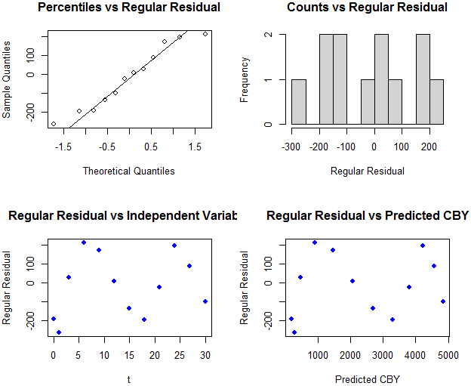

**Figure 9:** Residual Plots from Modified-Gompertz Regression Analysis

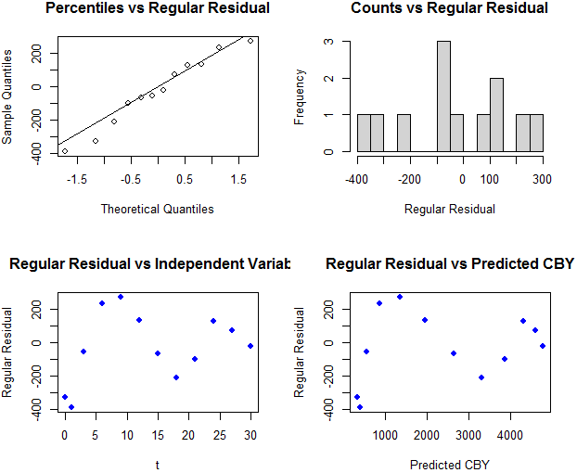

**Figure 10:** Residual Plots from Cone Regression Analysis

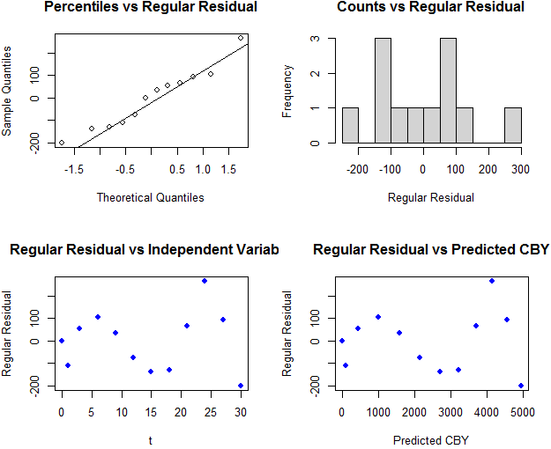

**Figure 11:** Residual Plots from Logistic Model Regression Analysis

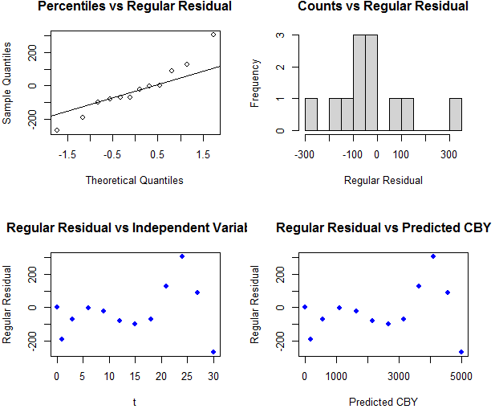

**Figure 12:** Residual Plots from First-Order Biogas Kinetics Regression Analysis

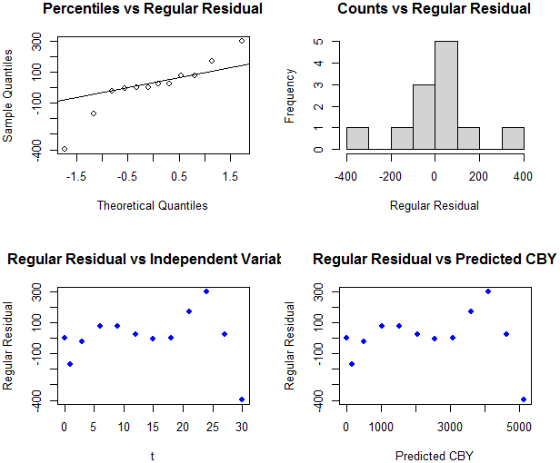

**Figure 13:** Residual Plots from Transference Biogas Kinetic Model Regression Analysis

In statistical analysis, comparing the Sample Quantile versus Theoretical Quantiles plot can help assess how well a model fits the data distribution. A strong alignment between the sample and theoretical quantiles in Figures 9-12 indicates a good fit of the modified Gompertz, Cone, First-Order and Logistic models to the data distribution, demonstrating that the model assumptions are met. Significant deviation from the straight line, suggests that the Transference model may not adequately represent the data distribution, indicating potential model inadequacies (Figure 13). The bars in the Frequency versus Regular Residual plots represent the distribution of residuals at different frequencies or levels of the independent variable. Regular residual is the difference between the observed value and the predicted value from the statistical model while the frequency refers to the number of observations or data points that fall within a particular range or category of the independent variable. When there are limited data points within a specific category, the frequency for that category may be low, such as 1, 2, or 3. Sparse data in certain categories can lead to frequencies of 1, 2, or 3, indicating that there are only a small number of observations at those levels. Peaks in the curve scatter points in Regular Residuals vs ‘t’ and ‘CBY’ plots can be attributed to various factors, including outliers, non-linear relationships, model misspecification, or data variability (162).

3.3. Optimization

A code that visualizes the relationship between the predictor and response variables, and provides the fitted model's performance is shown in Figure 14.

|  |
| --- |

**Figure 14:** RSM Optimization R Programming Language Program

This particular R programming language software presents the code text in ‘red’ font and the output in ‘blue’ text, as shown in Figure 14. The blue output after the R code is the analysis of variance (ANOVA) table, also examined for a simple regression modelling by Kamel & Abonazel (2023). For each term in the regression model, including the linear term, quadratic term, and any interaction terms, the p-value = 1.164 indicates the significance of that term in predicting the dependent variable. A low p-value (typically below a significance level, such as 0.05) suggests that the term is statistically significant, meaning that it has a significant impact on the dependent variable. F-statistic on the other hand, is used to test the overall significance of the regression model. A larger F-value = 721.3 suggests a better fit of the model to the data. A quadratic model given by Equation 1, resulted in the fitted plot presented in Figure 15.

(1)

A model, such as Equation 1 is a one-factor (in ‘t’) expression bearing semblance with an Excel-developed regression 3-factor model developed by Duong & Lim (2023). It is no surprise that this model is expected to perform better than some of the applied biogas kinetic model for the CM biogas CBY-RT relationship, in terms of R2 estimation. Figure 15 portrays a similar trend curve with the 4 best performing models.

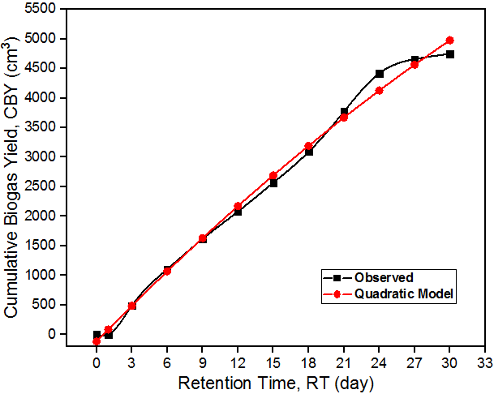

**Figure 15:** Predicted CBY by Quadratic Model versus Actual/Observed CBY Data

In continuation of the code pasted in the R window (i.e., Figure 14), R text code in Figure 16, if pasted will give the statistical metrics as well as the residual plot for the predicted quadratic model.

|  |
| --- |

**Figure 16:** Residual Statistics for the Quadratic Model

Upon reviewing the values in Table 4 and comparing them with the quadratic model result in Figure 16, we find that the quadratic model indeed demonstrates higher R2 and adjusted R2 values compared to most models examined. However, it's worth noting that the Logistic model exhibits a slightly higher R2 value of 0.9944 and a comparable adj. R2 value of 0.9922, indicating a slightly stronger overall fit than the quadratic model. Additionally, while the quadratic model shows a lower RMSE of 133.7645 compared to some models in Table 4, such as the Cone and Transference models, its RMSE is still higher than that of the Logistic model (127.6598). Furthermore, the quadratic model's RSS of 214715.2 is lower than some models in Table 4 but higher than that of the Logistic model (195564.3), indicating a relatively larger discrepancy between the observed and predicted values compared to the Logistic model. In that case, the quadratic model (Equation 1) is ranked second in terms of performance. Its favorable performance is linked to the good descriptive pattern of the residual plots in Figure 17.

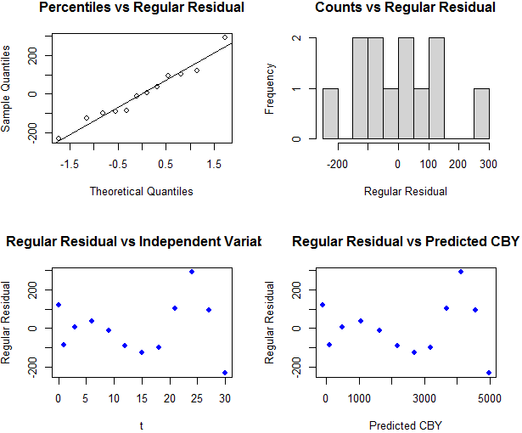

**Figure 17:** Residual Plots from Quadratic Model Describing the Biogas Yield

It is worthy of note that residual plots are generally used to check the assumptions of regression models, such as linearity, homoscedasticity (constant variance of residuals), independence of errors, and normality of residuals. Patterns in residual plots can indicate violations of these assumptions, prompting further investigation or potential model adjustments.

4. Conclusions

Twin data mining techniques involving exploratory data analysis or summary statistics and regression analysis for predicting continuous numerical value (in this case CBY) using R programming language were successfully executed for CM-AD dataset obtained over a 30 days RT. After a similar code for RSM optimization taking RT as the only predictor variable was run, the model that best describe the empirical result was discovered to be the Logistic followed by Quadratic and modified-Gompertz, having relatively lower RMSE and RSS values equivalent to 127.7 & 195564, 133.8 & 214715 and 156.2 & 292661, respectively. Based on a satisfactory Logistic model residual plots given by the R source code, its kinetic parameters including k = 0.0254 cm3/day, SF = 1.2737 and BP = 11934.13 cm3 were estimated with no warning or error notification. Herein, the SF value reported is high, corresponding to rapid degradation, favourable conditions and enhanced biogas production. An observed LP of 3 days is quite in agreement with 2.227 days and 3.6 days nonlinear regression predictions from modified-Gompertz and Cone models, respectively, but absolutely deviates from 0 LP given by the Transference kinetic equation, which suggests a quick onset of biogas production and is as such, the worst model. Since it is evident that R can be used to estimate the parameters of biogas kinetic models, effort should be made to present this using a flowchart and adopt it as additional potable regression and RSM optimization tool. Going forward, biogas potential of CM based on wet and dry fermentation in the thermophilic and psychrophilic temperature regimes need to be investigated for a simplified and effective approach, especially in locations experiencing different whether conditions. Already, inhibitions and nutrient sufficiency issues associated with CM mono-digestion have been resolved, according to literature, but not all kinetic models have been examined.

Acknowledgments

The authors are grateful to Mr. Nazir for providing us with the AutoCAD design of the bioreactor.

Funding

No financial support for the research and publication of this article was obtained from any Research Supporting Bodies, either local or international*.*

Author contributions

Conceptualization, A.M.A.; methodology, A.M.A.; validation, B.C. and A.A.M.; formal analysis, S.I.U and S.N.; investigation, T.S.; resources, T.S. and S.I.U.; data curation, S.N.; writing-original draft preparation, A.M.A.; writing-review and editing, M.J.A.; visualization, A.M.A.; supervision, T.S.; project administration, S.I.U. and; funding acquisition, S.I.U. and A.A.M. All authors have read and agreed to the published version of the manuscript.

Conflict of interest

There is no conflict of interest declared by the authors.

Data availability statement

Date supporting these findings are available within the article, at https://doi.org/10.20935/AcadEnergy6187, or upon request. Consent to further use the data in this journal in another publication must be sought and permission granted by the corresponding author.

Institutional review board statement

I am pleased to convey to you that the ethical approval for your project titled: “R Programming Estimation of Poultry Residue Biogas Kinetic Parameters” has been granted. Please note that you are required to adhere strictly to the protocol stated in your proposal. Should there be any substantial change in the protocol, a fresh application is required.

Informed consent statement

Not applicable.

Sample availability

CM samples used in the study have been exhausted and discarded. However, the bioreactor used in the study is still domiciled at UNIMAID Chemical Engineering Analysis Laboratory, and will be made available to interested persons only if it is still functional and undamaged. The bioreactor was designed and fabricated between September-October 2021 by Engr. ABDULHALIM MUSA ABUBAKAR to run a Master’s Degree Thesis Project in the institution.

Additional information

Received: 2024-03-31

Accepted: YYYY-MM-DD

Published: YYYY-MM-DD

Publisher’s note

Academia.edu stays neutral with regard to jurisdictional claims in published maps and institutional affiliations. All claims expressed in this article are solely those of the authors and do not necessarily represent those of their affiliated organizations, or those of the publisher, the editors, and the reviewers. Any product that may be evaluated in this article, or claim that may be made by its manufacturer, is not guaranteed or endorsed by the publisher.

Copyright

*© 2024 copyright by the authors. This article is an open access article distributed under the terms and conditions of the Creative Commons Attribution (CC BY) license (https:// creativecommons.org/licenses/by/4.0/).*

References

1. Abouelenien F, Nakashimada Y, Nishio N. Dry mesophilic fermentation of chicken manure for production of methane by repeated batch culture. J Biosci Bioeng [Internet]. 2009;107(3):293–295. Available from: <http://www.elsevier.com/locate/jbiosc>
2. Abubakar AM, Elshahhat A, Ndaba S, Mobolaji AT, Thiagarajan B, Mansour EM. Chemical engineering numerical analysis with R: Peng–Robinson equation of state. J Data Sci Intell Syst. 2023;1(1):25–44.
3. Abubakar AM, Silas K, Aji MM, Taura UH, Undiandeye J. Microbial growth rate kinetics in biogas production by anaerobic digestion of chicken manure. iRASD J Energy Environ [Internet]. 2023;3(2):72–89. Available from: <https://journals.internationalrasd.org/index.php/jee>
4. Abubakar AM, Silas K, Aji MM, Taura UH, Undiandeye J. Biogas production from chicken manure: Characterization and kinetic models. Bayero J Eng Technol [Internet]. 2022;17(3):1–13. Available from: <https://www.bayerojet.com>
5. Abubakar AM, Soltanifar Z, Luka Y, Udoh EW, Hamadou M. Analysis of microbial growth models for microorganisms in chicken manure digester. Int J Res Sci Eng [Internet]. 2021;1(2):1–24. Available from: <http://journal.hmjournals.com/index.php/IJRISE>
6. Adderley AE, Smith IE, Probert SD. Anaerobic fermentation of poultry manure. Appl Energy. 1976;2(3):163–73.
7. Ahmad MAA. Production of biogas from poultry manure [Internet]. Bachelor of Chemical Engineering (Biotechnology) Thesis, Faculty of Chemical and Natural Resources Engineering, Universiti Malaysia Pahang; 2010. Available from: <http://umpir.ump.edu.my/id/eprint/3179/>
8. Ali EBA-E, Hesham AM. Practical approach to improve biogas produced from poultry manure. Int J Eng Res Technol [Internet]. 2021;9(4):157–60. Available from: <http://www.ijert.org>
9. Ali R, Al-Sa’ed R. A novel process design for enhanced biogas production from poultry manure using a solar water heating system. Proc 14th Int Conf Environ Sci Technol [3-5 Sep, Rhodes, Greece]-Institute Environ Water Stud [Internet]. 2015;1–14. Available from: <http://hdl.handle.net/20.500.11889/4632>
10. Ali R, Al-Sa’ed R. Pilot-scale anaerobic digester for enhanced biogas production from poultry manure using a solar water heating system. Int J Environ Stud [Internet]. 2017;1–14. Available from: <http://www.tandfonline.com/loi/genv20>
11. Ali RS. Biogas production from poultry manure using a novel solar assisted system [Internet]. Al-Sa’ed R, Abu Madi M, Mahmoud N, editors. Degree of Master of Water and Environmental Sciences from Faculty of Graduate Studies at Birzeit University; 2015. Available from: <https://fada.birzeit.edu/bitstream/20.500.11889/1669/1/thesis_28072015_111212.pdf>
12. Al-Zoubi AI, Alkhamis TM, Alzoubi HA. Optimized biogas production from poultry manure with respect to pH, C/N, and temperature. Results Eng. 2024;22(102040):1–12.
13. Angeles WG, Rascón J, Gurbillón MÁB, Ramirez CMO, Oliva M, Santillan YM. Production of biogas from chicken manure using solar collectors. Rev Investig en Agroproducción Sustentable. 2021;5(2):44–9.
14. Ao T, Chen L, Chen Y, Liu X, Wan L, Li D. The screening of early warning indicators and microbial community of chicken manure thermophilic digestion at high organic loading rate. Energy. 2021;224(120201):1–9.
15. Archontoulis S V, Miguez FE. Nonlinear regression models and applications in agricultural research. Agron J. 2015;107(2):786–798.
16. Ardİc I, Taner F. Effects of thermal, chemical and thermochemical pretreatments to increase biogas production yield of chicken manure. Fresenius Environ Bull [Internet]. 2005;14(5):373–80. Available from: <https://www.cabidigitallibrary.org/doi/full/10.5555/20053106256>
17. Arriagada CB, Sanhueza PF, Guzmán-Fierro VG, Medina TI, Fernández KF, Roeckel MD. Efficient poultry manure management: anaerobic digestion with short hydraulic retention time to achieve high methane production. Poult Sci. 2019;98:6636–6643.
18. Arromdee P, Nawalerskasama A, Saewong N. Economic analysis of electricity generation from chicken manure by plug flow anaerobic digester and CSTR anaerobic digester. Silpakorn Univ J Soc Sci Humanit Arts [Internet]. 2017;17(3):27–50. Available from: <https://thaiscience.info/Journals/Article/SUIJ/10988630.pdf>
19. Arshad M, Bano I, Khan N, Shahzad MI, Younus M, Abbas M, et al. Electricity generation from biogas of poultry waste: An assessment of potential and feasibility in Pakistan. Renew Sustain Energy Rev. 2018;81:1241–6.
20. Anjum R, Grohmann E, Krakat N. Anaerobic digestion of nitrogen rich poultry manure: Impact of thermophilic biogas process on metal release and microbial resistances. Chemosphere. 2017;168:1637–47.
21. Antognoni S, Ragazzi M, Ionescu G, Passamani G, Zanoni S, Rada EC, et al. Respirometric index as a tool for biogas generation production from poultry manure. Manag Environ Qual [Internet]. 2016;27(3):269–80. Available from: <https://www.emerald.com/insight/content/doi/10.1108/MEQ-04-2015-0052/full/html>
22. Anupoju GR, Ahuja S, Gandu B, Sandhya K, Kuruti K, Yerramsetti VS. Biogas from poultry litter: A review on recent technological advancements. In: Ravindra P, editor. Advances in Bioprocess Technology. Springer, Cham; 2022. p. 133–147.
23. Ao T, Chen L, Zhou P, Liu X, Li D. The role of oxidation-reduction potential as an early warning indicator, and a microbial instability mechanism in a pilot-scale anaerobic mesophilic digestion of chicken manure. Renew Energy. 2021;179:223–32.
24. Baltrėnas P, Kolodynskij V, Urbanas D. Biogas production from chicken manure at different organic loadings using a special zeolite additive (ZeoVit sorbent). J Renew Sustain Energy. 2019;11(063101):1–11.
25. Baltrėnas P, Kolodynskij V. Experimental research of efficiency of semi-continuous and periodic biogas production processes by using chicken manure bioloadings. Water Environ Res. 2020;92(5):722–30.
26. Baltrėnas P, Paliulis D, Kolodynskij V. The experimental study of biogas production when digesting chicken manure with a biochar additive. Green House Gases Sci Technol. 2019;9(4):837–47.
27. Baki UH, Hakan Bayraktar Ö, I A, Cengiz AR. Evaluation possibilities of chicken manure in Turkey. Agric Eng [Internet]. 2015;19(2):5–14. Available from: <http://ir.ptir.org>
28. Baty F, Ritz C, Charles S, Brutsche M, Flandrois J-P, Delignette-Muller M-L. A toolbox for nonlinear regression in R: The package nlstools. J Stat Softw [Internet]. 2015;66(5):1–21. Available from: <http://www.jstatsoft.org/>
29. Bayrakdar A, Sürmeli RÖ, Çalli B. Anaerobic digestion of chicken manure by a leach-bed process coupled with side-stream membrane ammonia separation. Bioresour Technol. 2018;258:41–7.
30. Bayrakdar A, Sürmeli RÖ, Çalli B. Dry anaerobic digestion of chicken manure coupled with membrane separation of ammonia. Bioresour Technol. 2017;244:816–23.
31. Belostotskiy D, Jacobi HF, Strach K, Liebetrau J. Anaerobic digestion of chicken manure as a single substrate by control of ammonia concentration. Redbiogas.cl [Internet]. 2014;1–4. Available from: <http://www.redbiogas.cl/wp-content/uploads/2013/07/IWA-11342.pdf>
32. Belostotskiy DE, Ziganshina EE, Siniagina M, Boulygina EA, Miluykov VA, Ziganshin AM. Impact of the substrate loading regime and phosphoric acid supplementation on performance of biogas reactors and microbial community dynamics during anaerobic digestion of chicken wastes. Bioresour Technol. 2015;193:42–52.
33. Bhatnagar N, Ryan D, Murphy R, Enright A-M. Trace element supplementation and enzyme addition to enhance biogas production by anaerobic digestion of chicken litter. Energies [Internet]. 2020;13(3477):1–13. Available from: <http://www.mdpi.com/journal/energies>
34. Bi S, Qiao W, Xiong L, Mahdy A, Wandera SM, Yin D, et al. Improved high solid anaerobic digestion of chicken manure by moderate in situ ammonia stripping and its relation to metabolic pathway. Renew Energy. 2020;146:2380–9.
35. Bi S, Westerholm M, Hu W, Mahdy A, Dong T, Sun Y, et al. The metabolic performance and microbial communities of anaerobic digestion of chicken manure under stressed ammonia condition: A case study of a 10-year successful biogas plant. Renew Energy. 2021;167:644–51.
36. Bijman T. Biogas from poultry waste – A case. In: Dorset symposium [June 2014]-Nijhuis Water Technology [Internet]. Netherlands; 2014. p. 1–12. Available from: <https://www.dorset.nu/wp-content/uploads/2018/07/A-15.00-1-43EN-T.-Bijman-Biogas-from-poultry-waste.pdf>
37. Bi S, Qiao W, Xiong L, Ricci M, Adani F, Dong R. Effects of organic loading rate on anaerobic digestion of chicken manure under mesophilic and thermophilic conditions. Renew Energy. 2019;139:242–50.
38. Bi S, Westerholm M, Qiao W, Mahdy A, Xiong L, Yin D, et al. Enhanced methanogenic performance and metabolic pathway of high solid anaerobic digestion of chicken manure by Fe2+ and Ni2+ supplementation. Waste Manag [Internet]. 2019;94:10–7. Available from: <http://www.elsevier.com/locate/wasman>
39. Braeutigam P, Franke M, Ondruschka B. Effect of ultrasound amplitude and reaction time on the anaerobic fermentation of chicken manure for biogas production. Biomass and Bioenergy. 2014;63:109–13.
40. Brockotter F. China’s first chicken manure-biogas plant. Poultry World-Misset Uitgeverij BV [Internet]. 2008 Aug 8;1–2. Available from: <https://www.poultryworld.net/home/chinas-first-chicken-manure-biogas-plant/>
41. Bujoczek G, Oleszkiewicz JA, Sparling R, Cenkowski S. High solid anaerobic digestion of chicken manure. J Agric Eng Res [Internet]. 2000;76(1):51–60. Available from: <https://www.researchgate.net/publication/223654589>
42. Busato CJ, Ros C Da, Pellay R, Barbierato P, Pavan P. Anaerobic membrane reactor: Biomethane from chicken manure and high-quality effluent. Renew Energy. 2020;145:1647–57.
43. Cai Y, Gallegos D, Zheng Z, Stinner W, Wang X, Sch F. Exploring the combined effect of total ammonia nitrogen, pH and temperature on anaerobic digestion of chicken manure using response surface methodology and two kinetic models. Bioresour Technol. 2021;337(125328):1–10.
44. Cai Y, Janke L, Zheng Z, Wang X, Pröter J, Schäfer F. Enhancing anaerobic digestion of chicken manure leachate: Effects of trace elements supplementation on methane production. Bioresour Technol Reports. 2021;14(100662):1–5.
45. Cai Y, Janke L, Meng X, Zheng Z, Zhao X, Pröter J, et al. The absolute concentration and bioavailability of trace elements: Two vital parameters affecting anaerobic digestion performance of chicken manure leachate. Bioresour Technol. 2022;350(126909).
46. Carmona PCR, Witaszek K, Janczak D, Czekala W, Lewicki A, Dach J, et al. Methane fermentation of the poultry manure as an alternative and environmentally friendly technology of its management. Arch Waste Manag Environ Prot [Internet]. 2014;16(1):21–6. Available from: <http://awmep.org>
47. Chen J, Li J, Ye B, Zhang X, Tyagi RD, Gao X. Energy balance assessment on chicken manure for biogas production in Rabat-Salé-Zemmour-Zaïr of Morocco. J Environ Manage [Internet]. 2021;299(113656):1–7. Available from: <http://www.elsevier.com/locate/jenvma>
48. Chen B, Shao Y, Shi M, Ji L, He Q, Yan S. Anaerobic digestion of chicken manure coupled with ammonia recovery by vacuum-assisted gas-permeable membrane process. Biochem Eng J. 2021;175(108135).
49. Chen Y, Tian Z, Wang Y, Zhang C, He L, Zhao X. Response of fulvic acid linking to redox characteristics on methane and short-chain fatty acids in anaerobic digestion of chicken manure. J Environ Manage. 2024;354(120357).
50. Chun CW, Jamaludin NFM, Zainol N. Optimization of biogas production from poultry manure wastewater in 250 mL flasks. J Teknol [Internet]. 2015;75(1):275–85. Available from: [www.jurnalteknologi.utm.my](http://www.jurnalteknologi.utm.my)
51. Coban V, Sarac HI, Kaya D, Eyidogan M, Cagman S. Effects of various nitrogen rates to biogas production yield in anaerobic digestion of only chicken manure. Life Sci J [Internet]. 2014;11(2):186–90. Available from: <http://www.lifesciencesite.com>
52. Czekała W, Dach J, Lewicki A, Gajewska K, Staszak Ż. Utilization of digestate obtained from methane fermentation of chicken manure. In: IX International Scientific Symposium “Farm Machinery and Processes Management in Sustainable Agriculture” [Lublin, Poland, 2017] [Internet]. 2017. p. 92–6. Available from: <https://depot.ceon.pl/handle/123456789/14832>
53. Dalkilic K, Ugurlu A. Biogas production from chicken manure at different organic loading rates in a mesophilic-thermopilic two stage anaerobic system. J Biosci Bioeng [Internet]. 2015;xx(xx):1–8. Available from: <http://www.elsevier.com/locate/jbios>
54. Dalkilic K, Ugurlu A. Biogas production from chicken manure. J Poult Res [Internet]. 2013;10(1):14–9. Available from: <https://dergipark.org.tr/en/download/article-file/419890>
55. Dalkılıç K, Uğurlu A. Influence of hydraulic retention time and reactor configuration during fermentation of diluted chicken manure. Appl Biochem Biotechnol [Internet]. 2017;181:157–176. Available from: <https://link.springer.com/article/10.1007/s12010-016-2205-6>
56. de Oliveira MP, Paranhos AG de O, Adarme OFH, de Aquino SF. Hydrothermal pretreatment of poultry litter for biogas production. Brazilian J Agric Environ Eng [Internet]. 2023;27(11):873–81. Available from: <http://www.scielo.br/rbeaa>
57. Di L, Zhang Q, Wang F, Wang H, Liu H, Yi W, et al. Effect of nano-Fe3O4 biochar on anaerobic digestion of chicken manure under high ammonia nitrogen concentration. J Clean Prod. 2022;375(134107).
58. Dróżdż D, Wystalska K, Malińska K, Grosser A, Grobelak A, Kacprzak M. Management of poultry manure in Poland – Current state and future perspectives. J Environ Manage. 2020;264(110327):1–16.
59. Dosoretz C, Lamed R. Chicken manure methanogenesis. 1. Selective inhibition of acetate conversion to methane. Poult Sci [Internet]. 1987;66:576–85. Available from: <https://pdf.sciencedirectassets.com/776861/1-s2.0-S0032579119X6650X>
60. Dubrovskis V, Plume I, Straume I. Broiler house litter processing by anaerobic digestion using enzymes. Biointerface Res Appl Chem. 2020;10(3):5418–22.
61. Duong CM, Lim T-T. Use of regression models for development of a simple and effective biogas decision‑support tool. Sci Rep [Internet]. 2023;13(4933):1–11. Available from: [www.nature.com/scientificreports](http://www.nature.com/scientificreports)
62. Du T, Feng L, Zhen X. Microbial community structures and antibiotic biodegradation characteristics during anaerobic digestion of chicken manure containing residual enrofloxacin. J Environ Sci Heal Part B. 2022;57(2):102–13.
63. Ebrahem ME, Moustafa MM, Abdel-Salam MF. Biogas utilization system for warming poultry houses. MISR J Agric Eng [Internet]. 2022;39(2):341–52. Available from: <https://mjae.journals.ekb.eg>
64. Elasri O, Afilal ME amin. Potential for biogas production from the anaerobic digestion of chicken droppings in Morocco. Int J Recycl Org Waste Agric. 2016;5:195–204.
65. Elasri O, Salem M, Ramdani M, Zaraali O, Lahbib L. Effect of increasing inoculum ratio on energy recovery from chicken manure for better use in Egyptian agricultural farms. Chem Biol Technol Agric. 2018;5(17):1–7.
66. Emadian S, Kuzulcan M, Küçüker MA, Demirel B, Onay TT. Enzymatic pretreatment of chicken manure for improved biogas yield. In: Naddeo V, Balakrishnan M, Choo KH, editors. Frontiers in Water-Energy-Nexus—Nature-Based Solutions, Advanced Technologies and Best Practices for Environmental Sustainability Advances in Science, Technology & Innovation. Springer, Cham; 2019. p. 357–358.
67. Fakkaew K, Polprasert C. Air stripping pre-treatment process to enhance biogas production in anaerobic digestion of chicken manure wastewater. Bioresour Technol Reports. 2021;14(100647):1–7.
68. Farrow C. Anaerobic digestion of poultry manure: Implementation of ammonia control to optimize biogas yield [Internet]. McBean E, Crolla A, Kinsley C, editors. Degree of Doctor of Philosophy in Engineering Thesis, The University of Guelph; 2016. Available from: <https://dam-oclc.bac-lac.gc.ca/download?is_thesis>
69. Farrow C, Crolla A, Kinsley C, McBean E. Ammonia removal from poultry manure leachate via struvite precipitation: a strategy for more efficient anaerobic digestion. Int J Environ Technol Manag [Internet]. 2017;20(1/2):87–100. Available from: <https://ideas.repec.org/a/ids/ijetma/v20y2017i1-2p87-100.html>
70. Feng W, Nan YX, Zhen YH. Treatment process of anaerobically digested effluent of chicken manure for meeting the discharging standard. Nongye Jixie Xuebao = Trans Chinese Soc Agric Mach [Internet]. 2012;43(5):84–90. Available from: <http://www.agro-csam.org/njxb/>
71. Fox J, Weisberg S. Nonlinear regression and nonlinear least squares in R. In: An Appendix to An R Companion to Applied Regression. 2nd ed. 2013. p. 1–20.
72. Fuchs W, Wang X, Gabauer W, Ortner M, Li Z. Tackling ammonia inhibition for efficient biogas production from chicken manure: Status and technical trends in Europe and China. Renew Sustain Energy Rev [Internet]. 2018;97:186–99. Available from: <https://www.sciencedirect.com/science/article/abs/pii/S1364032118306221>
73. Gosch A, Mertens H, Wenske U, Jaeger W. Anaerobic treatment of chicken manure [biogas]. In: AGRIS-International System for Agricultural Science and Technology [Internet]. Grundlagen der Landtechnik (Germany, F.R.); 1982. p. 96–100. Available from: <https://agris.fao.org/search/en/providers/122514/records/64774d8ff2e6fe92b363dbac>
74. Guo H, Zhao S, Xia D, Zhao W, Li Q, Liu X, et al. The biochemical mechanism of enhancing the conversion of chicken manure to biogenic methane using coal slime as additive. Bioresour Technol. 2022;344(126226).
75. Haque ME, Ryndin R, Mang H-P, Kabir H, Rahman MM, Khasruzzaman AKM, et al. Assessment of biogas production and bacterial load from manure of layer chicken fed with two different types of feed. JSFA Reports. 2022;2(10):472–9.
76. He X, Hu Q, Chen J, Leong WQ, Dai Y, Wang C-H. Energy and environmental risk assessments of poultry manure sustainable solution: An industrial case study in Singapore. J Clean Prod. 2022;339(130787).
77. Heng LK. Bio gas plant green energy from poultry wastes in Singapore. In: World Engineers Summit – Applied Energy Symposium & Forum: Low Carbon Cities & Urban Energy Joint Conference, WES-CUE 2017, 19–21 July 2017, Singapore. 2017. p. 436–41.
78. Hewson P. Statistical tools for nonlinear regression: A practical guide with S-PLUS and R examples. J R Stat Soc. 2005;168(1):254–254.
79. Hills DJ. Chemical characteristics of and methane production from turkey manure. Poult Sci. 1982;61(4):677–84.
80. Hu F, Zhai H, Yang Y, Tian Y, Wang J, Qiang H. The effects of chlortetracycline on anaerobic digestion of chicken manure and the role of extracellular polymeric substances. J Clean Prod. 2022;367(133014).
81. Huang JJH, Shih JCH. The potential of biological methane generation from chicken manure. Biotechnol Bioeng. 1981;23(10):2307–14.
82. Hurst G, Ruiz-Lopez S, Rivett D, Tedesco S. Effect of hydrochar from acid hydrolysis on anaerobic digestion of chicken manure. J Environ Chem Eng. 2022;10(5).
83. Ibrahim GII, Wei GG, Fu ZJ, Tayel SA, Khairy MFA, El-Shima SA. Anaerobic digestion for waste water poultry manure by UBF reactor. J Environ Sci [Internet]. 1997;9(2):149–61. Available from: <https://www.cabidigitallibrary.org/doi/full/10.5555/19982400243>
84. IEA. Minhe chicken manure biogas plant-Circular economy management of chicken manure [Internet]. DONG Renjie; 2021. Available from: <http://task37.ieabioenergy.com>
85. Janczak D, Mazurkiewicz J, Czekała W, Myszura M, Kozłowski K, Jeżowska A. A possibility of functioning biogas plant at a poultry farm. J Ecol Eng. 2019;20(11):225–231.
86. Jensen AP, Ostergaard O. Method for poultry litter fermentation and biogas production [Internet]. WO 2017/080565, 2017. p. 1–68. Available from: <https://patents.google.com/patent/WO2017080565A1/en>
87. Johari SAM, Aqsha A, Shamsuddin R, Lam MK, Osman N, Tijani M. Technical trends in biogas production from chicken manure. In: Jawaid M, Khan A, editors. Manure Technology and Sustainable Development, Sustainable Materials and Technology. Springer Nature Singapore Pte Ltd; 2023. p. 145–82.
88. Jiang H, Li T, Stinner W, Nie H, Ding J, Zhou H. Selection of in-situ desulfurizers for chicken manure biogas and prediction of dosage. Polish J Environ Stud. 2017;26(1):155–61.
89. Jiang Z, Steinsberger SC, Shih JCH. In situ utilization of biogas on a poultry farm: Heating, drying and animal brooding. Biomass. 1987;14(4):269–81.
90. Jung J-M, Oh J-I, Park Y-K, Lee J, Kwon EE. CO2-mediated chicken manure biochar manipulation for biodiesel production. Environ Res. 2019;171:348–55.
91. Jurgutis L, Slepetiene A, Volungevicius J, Amaleviciute-Volunge K. Biogas production from chicken manure at different organic loading rates in a mesophilic full scale anaerobic digestion plant. Biomass and Bioenergy. 2020;141(105693):1–10.
92. Kamel AR, Abonazel MR. A simple introduction to regression modeling using R. Comput J Math Stat Sci [Internet]. 2023;2(1):52–79. Available from: <https://cjmss.journals.ekb.eg/>
93. Kalogiannis A, Vasiliadou IA, Spyridonidis A, Diamantis V, Stamatelatou K. Biogas production from chicken manure wastes using an LBR-CSTR two-stage system: Process efficiency, economic feasibility, and carbon dioxide footprint. J Chmeical Technol Biotechnol [Internet]. 2022;1–10. Available from: [www.soci.org](http://www.soci.org)
94. Karaalp D, Doruk N, Dizge N, Keskinler B, Azbar N. A novel solution for biogas applications in poultry industry: CLAMBS approach. Bioprocess Biotech. 2015;5(2):1–6.
95. Karichappan T, Venkatachalam S, Jeganathan PM. Investigation on biogas production process from chicken processing industry wastewater using statistical analysis: Modelling and optimization. J Renew Sustain Energy. 2014;6(4):1–10.
96. Kocak E, Yetilmezsoy K, Ozturk M. A small-scale biogas digester model for hen manure treatment: Evaluation and suggestions. Fresenius Environ Bull [Internet]. 2007;16(7):804–11. Available from: <https://www.build-a-biogas-plant.com/PDF/Kaan_yetilmez_HenManure2007.pdf>
97. Konkol I, Swierczek L, Cenian A. Chicken manure pretreatment for enhancing biogas and methane production. Zelic B, editor. Energies [Internet]. 2023;16(5442):1–13. Available from: <https://www.mdpi.com/journal/energie>
98. Kenge N, Jason M. Thermophilic anaerobic digestion of chicken manure [Internet]. Euverink GJW, Picchioni F, editors. Master’s Thesis/ Essay, Chemical Engineering, Faculty of Science and Engineering, University of Southampton; 2022. Available from: <https://fse.studenttheses.ub.rug.nl/id/eprint/27355>
99. Keskin T, Arslan K, Karaalp D, Azbar N. The determination of the trace element effects on basal medium by using the statistical optimization approach for biogas production from chicken manure. Waste and Biomass Valorization. 2018;0(0):1–10.
100. Kreidenweis U, Breier J, Herrmann C, Libra J, Prochnow A. Greenhouse gas emissions from broiler manure treatment options are lowest in well-managed biogas production. J Clean Prod. 2021;280(124969):1–12.
101. Kirby ME, Mirza MW, Davies J, Ward S, Theodorou MK. A novel nitrogen removal technology pre-treating chicken manure, prior to anaerobic digestion. Sustainability. 2020;12(7463):1–19.
102. Kirby ME, Mirza MW, Leigh T, Oldershaw L, Reilly M, Jeffery S. Destruction of Staphylococcus aureus and the impact of chlortetracycline on biomethane production during anaerobic digestion of chicken manure. Heliyon [Internet]. 2019;5(e02749):1–6. Available from: <http://www.heliyon.com>
103. Kizito S, Jjagwe J, Mdondo SW, Nagawa CB, Bah H, Tumutegyereize P. Synergetic effects of biochar addition on mesophilic and high total solids anaerobic digestion of chicken manure. J Environ Manage. 2022;315(115192).
104. Kolodynskij V, Baltrėnas P. Experimental research of biogas yield and quality produced from chicken manure. In: Environmental Engineering Proceedings of the International Conference on Environmental Engineering ICEE; Vilnius [Internet]. 2017. p. 1–1. Available from: <http://enviro.vgtu.lt/>
105. Kucuker MA, Demirel B, Onay TT. Enhanced biogas production from chicken manure via enzymatic pretreatment. J Mater Cycles Waste Manag. 2020;22:1521–1528.
106. Laiche H, Erraji H, Asehraou A. Optimizing anaerobic digestion from chicken droppings: Impact of inoculation with IL and IL-KT01 inoculums on specific biogas production. Biomass Convers Biorefinery. 2024;X–XX.
107. Lam T-K, Yang J-T, Lai S-J, Liang S-Y, Wu S-H. Meta-proteomics analysis of microbial ecosystem during the anaerobic digestion of chicken manure in biogas production farm. Bioresour Technol Reports [Internet]. 2021;13(100643):1–9. Available from: <https://www.sciencedirect.com/science/article/abs/pii/S2589014X21000207>
108. Lewicki A, Kozlowski K, Pietrowski M, Zbytek Z. Methane fermentation of chicken droppings. J Res Appl Agric Eng. 2016;61(4):28–30.
109. Liang Y, Qiu L, Guo X, Pan J, Lu W, Ge Y. Start-up performance of chicken manure anaerobic digesters amended with biochar and operated at different temperatures. Nat Environ Pollut Technol [Internet]. 2017;16(2):615–21. Available from: <https://neptjournal.com/upload-images/NL-60-39-(37)D-557com.pdf>
110. Li K, Liu R, Yu Q, Ma R. Removal of nitrogen from chicken manure anaerobic digestion for enhanced biomethanization. Fuel. 2018;232:395–404.
111. Li Y, Wang C, Xu X, Sun Y, Xing T. Bioaugmentation with a propionate-degrading methanogenic culture to improve methane production from chicken manure. Bioresour Technol. 2022;346(126607).
112. Li Z, Wang G, Cao Z, Sui C, Zou J, Wang Z. Effects of different addition ratios of unsterilized chicken manure biogas slurry on Chlorella cultivation. Energy Sources, Part A Recover Util Environ Eff. 2020;1–11.
113. Linsong H, Lianhua L, Ying L, Changrui W, Yongming S. Bioaugmentation with methanogenic culture to improve methane production from chicken manure in batch anaerobic digestion. Chemosphere. 2022;303(135127).
114. Liu XY, Wang JJ, Nie JM, Wu N, Yang F, Yang RJ. Biogas production of chicken manure by two-stage fermentation process. In: E3S Web of Conferences (ICEMEE 2018). 2018. p. 5–8.
115. Liu Z-G, Zhou X-F, Zhang Y-L, Zhu H-G. Enhanced anaerobic treatment of CSTR-digested effluent from chicken manure: The effect of ammonia inhibition. Waste Manag. 2012;32(1):137–43.
116. Ma J, Chen F, Xue S, Pan J, Khoshnevisan B, Yang Y, et al. Improving anaerobic digestion of chicken manure under optimized biochar supplementation strategies. Bioresour Technol. 2021;325(124697):1–12.
117. Mahadevaswamy M, Venkataraman L V. Bioconversion of poultry droppings for biogas and algal production. Agric Wastes. 1986;18(2):93–101.
118. Mahato P, Rajagopal R, Goyette B, Adhikary S. Low-temperature anaerobic digestion of chicken manure at high organic and nitrogen loads - strategies for controlling short chain fatty acids. Bioresour Technol. 2022;351(127049).
119. Mahato P, Adhikary S, Goyette B, Rajagopal R. Two-stage (liquid-solid) anaerobic mono-digestion of ammonia-rich chicken manure at low-temperature: Operational strategy and techno-economic assessment. Resour Conserv Recycl Adv. 2023;19(200168):1–12.
120. Mahdy A, Bi S, Song Y, Qiao W, Dong R. Overcome inhibition of anaerobic digestion of chicken manure under ammonia-stressed condition by lowering the organic loading rate. Bioresour Technol Reports. 2020;9(100359):1–37.
121. Mahdy A, Song Y, Salama A, Qiao W, Dong R. Simultaneous H2S mitigation and methanization enhancement of chicken manure through the introduction of the micro-aeration approach. Chemosphere. 2020;253(126687):1–9.
122. Makhsumkhanov AA, Pulatova OM, Alimova BK, Sadullaev ST, Tashbaev SA, Sarynsakhodzhaev AR, et al. Biogas production based on thermophilic methanogenic fermentation of chicken manure. Appl Sol Energy. 2024;59:770–777.
123. Manogaran MD, Shamsuddin R, Yusoff MHM, Lay M, Siyal AA. A review on treatment processes of chicken manure. Clean Circ Bioeconomy [Internet]. 2022;2(100013):1–11. Available from: [www.elsevier.com/locate/clcb](http://www.elsevier.com/locate/clcb)
124. environmental advantages of biogas production from poultry manure in Iran. Renew Energy. 2020;159:87–106.
125. Marchioro V, Steinmetz RLR, do Amaral AC, Gaspareto TC, Treichel H, Kunz A. Poultry litter solid state anaerobic digestion: Effect of digestate recirculation intervals and substrate/inoculum ratios on process efficiency. Amon B, Zhu J, editors. Front Sustain Food Syst [Internet]. 2018;2(46):1–10. Available from: <http://www.frontiersin.or>
126. Markou G. Improved anaerobic digestion performance and biogas production from poultry litter after lowering its nitrogen content. Bioresour Technol. 2015;196:726–30.
127. Membrez Y, Clement-Arnold E, Schwitzguebel J-P, Dubois B, Kuhn C, Heckly C. Recovery of bio energy from poultry manure ('Galigaz’); Valorisation bioenergetique de fumiers de volailles ('Galigaz’) [Internet]. Switzerland; 2000. Available from: <https://www.osti.gov/etdeweb/biblio/20371143>
128. Molaey R, Bayrakdar A, Sürmeli RÖ, Çalli B. Anaerobic digestion of chicken manure: Influence of trace element supplementation. Eng Life Sci. 2019;19(2):143–50.
129. Molaey R, Bayrakdar A, Çalli B. Long-term influence of trace element deficiency on anaerobic mono-digestion of chicken manure. J Environ Manage. 2018;223:743–8.
130. Molaey R, Bayrakdar A, Sürmeli RÖ, Çalli B. Influence of trace element supplementation on anaerobic digestion of chicken manure: Linking process stability to methanogenic population dynamics. J Clean Prod. 2018;181:794–800.
131. Molaey R, Bayrakdar A, Sürmeli RÖ, Çalli B. Anaerobic digestion of chicken manure: Mitigating process inhibition at high ammonia concentrations by selenium supplementation. Biomass and Bioenergy. 2018;108:439–46.
132. Neupane SK. Biogas production from poultry faeces. Innov Energy Res. 2018;7(4):1–6.
133. Ngaram SM, M S, Zungum IU, Tijjani A, Audu MY, Mohammed IB. Biogas generation from poultry manure. Gashua J Sci Humanit [Internet]. 2016;2(2):43–7. Available from: <http://www.fugagjsh.com>
134. Ngo T, Khudur LS, Hakeem IG, Shah K, Surapaneni A, Ball AS. Wood biochar enhances the valorisation of the anaerobic digestion of chicken manure. Clean Technol. 2022;4(2):420–39.
135. Nie H, Jacobi HF, Strach K, Xu C, Zhou H, Liebetrau J. Mono-fermentation of chicken manure: Ammonia inhibition and recirculation of the digestate. Bioresour Technol. 2015;178:238–46.
136. Niu Q, Kubota K, Qiao W, Jing Z, Zhang Y, Yu-You L. Effect of ammonia inhibition on microbial community dynamic and process functional resilience in mesophilic methane fermentation of chicken manure. J Chem Technol Biotechnol. 2015;90(12):2161–9.
137. Niu Q, Takemura Y, Kubota K, Li Y-Y. Comparing mesophilic and thermophilic anaerobic digestion of chicken manure: Microbial community dynamics and process resilience. Waste Manag. 2015;43:114–22.
138. Niu Q, Qiao W, Qiang H, Hojo T, Li Y-Y. Mesophilic methane fermentation of chicken manure at a wide range of ammonia concentration: Stability, inhibition and recovery. Bioresour Technol. 2013;137(4):358–67.
139. Oosterkamp WJ. Chicken manure digestion. Curr Biochem Eng. 2017;4(3):181–7.
140. Ortakci S, Yesil H, Tugtas AE. Ammonia removal from chicken manure digestate through vapor pressure membrane contactor (VPMC) and phytoremediation. Waste Manag [Internet]. 2019;85:186–194. Available from: <http://www.elsevier.com/locate/wasman>
141. Othman MYH, Yatim B, Salleh MM. Chicken dung biogas power generating system in Malaysia. Renew Energy. 1996;9(1–4):930–3.
142. Oyewole OA. Biogas production from chicken droppings. Sci World J [Internet]. 2010;5(4):11–4. Available from: <http://www.scienceworldjournal.org>
143. Pan J, Ma J, Liu X, Zhai L, Ouyang X, Liu H. Effects of different types of biochar on the anaerobic digestion of chicken manure. Bioresour Technol. 2019;275:258–65.
144. Pan J, Ma J, Zhai L, Liu H. Enhanced methane production and syntrophic connection between microorganisms during semi-continuous anaerobic digestion of chicken manure by adding biochar. J Clean Prod. 2019;240(118178):1–9.
145. Peddada SD, Haseman JK. Analysis of nonlinear regression models: A cautionary note. Dose-Response An Int J. 2005;3(4):342–352.
146. Pekyavas G, Dereli RK, Yangin-Gomec C. Comparative assessment of modeling and experimental data of ammonia removal from pre-digested chicken manure. Toxic/Hazardous Subst Environ Eng. 2020;55(11):1333–8.
147. Qiao W, Bi S, Yin D-M, Jiang M, Algapani D, Dong R. Biogas production potential and kinetics of chicken manure methane fermentation under mesophilic and thermophilic conditions. Zhongguo Huanjing Kexue/China Environ Sci [Internet]. 2018;38(1):234–43. Available from: <http://www.cnki.net>
148. Qiao W, Bi S-J, Xiong L-P, Ren Z-R, Dong R-J. Effect of feed concentration on long-term thermophilic methane fermentation of chicken manure. China Environ Sci. 2018;38(7):2593–601.
149. Qiao W, Bi S-J, Xiong L-P, Xin-Xin J, Dong R-J. Effects of ammonium on methane fermentation of chicken manure under mesophilic and thermophilic conditions. China Environ Sci [Internet]. 2019;39(7):2921–7. Available from: <http://www.zghjkx.com.cn/EN/>
150. Razek TMA, Amin MA, Ali EBA. Utilization of poultry manure in biogas production as an alternative to liquefied petroleum gas. J Environ Sci [Internet]. 2018;41(2):1–15. Available from: <https://jes.journals.ekb.eg/article_21015>
151. Reyes YA, Barrera EL, Cheng K. A review on the prospective use of chicken manure leachate in high-rate anaerobic reactors. J Environ Chem Eng. 2021;9(1):1–64.
152. Ribeiro EM, Barros RM, Filho GLT, dos Santos IFS, Sampaio LC, dos Santos T V, et al. Feasibility of biogas and energy generation from poultry manure in Brazil. Waste Manag Res J a Sustain Circ Econ [Internet]. 2018;36(3):221–35. Available from: <https://journals.sagepub.com/doi/abs/10.1177/0734242X17751846>
153. Ritz C, Streibig JC. Nonlinear regression with R (Use R!). 1st ed. Ritz C, Streibig JC, editors. Springer Science; 2008. 148 p.
154. Rodrigue KA, Donatien EA, Sylvie KAT, Marie-Emmanuelle TA, Cyril KM, Eric AK, et al. Dimensioning of an anaerobic digester for the treatment of chicken manure and for the production of biogas: The case study of a Chicken Farm in Yaokokoroko (Côte d’Ivoire). Green Sustain Chem [Internet]. 2022;12(4):91–103. Available from: <https://www.scirp.org/pdf/gsc_2022111014502811.pdf>
155. Rubežius M, Venslauskas K, Navickas K, Bleizgys R. Influence of aerobic pretreatment of poultry manure on the biogas production process. Processes. 2020;8(9):1–12.
156. Ruckstuhl A. Introduction to nonlinear regression [Internet]. 2016. 1–41 p. Available from: <http://www.idp.zhaw.ch>
157. Ryan TP. Education and training: Modern regression analysis for scientists and engineers [Internet]. Heydemann S, Toman B, editors. National Institute of Standards of Technology (NIST); 2003. 192 p. Available from: <http://www-i.nist.gov/cgi-bin/training.cgi>
158. Safley LM, Vetter RL, Smith D. Operating a full-scale poultry manure anaerobic digester. Biol Wastes [Internet]. 1987;19(2):79–90. Available from: <https://www.sciencedirect.com/science/article/abs/pii/0269748387901029>
159. Sakar S, Yetilmezsoy K, Kocak E. Anaerobic digestion technology in poultry and livestock waste treatment — a literature review. Waste Manag Res J a Sustain Circ Econ [Internet]. 2009;27(1). Available from: <https://journals.sagepub.com/doi/abs/10.1177/0734242X07079060>
160. Salyuk A, Zhadan S, Shapovalov E. Thermophilic methane digestion of chicken manure. Ukr Food J [Internet]. 2014;3(4):587–670. Available from: <https://cabidigitallibrary.org>
161. Salyuk A, Zhadan S, Shapovalov E. Thermophilic methane fermentation of chicken manure in a wide range of substrate moisture contents. J Food Packag Sci Tech Technol [Internet]. 2015;7:36–40. Available from: <https://dspace.nuft.edu.ua/server/api/core/bitstreams>
162. Savery CW, Cruzan DC. Methane recovery from chicken manure digestion. J (Water Pollut Control Fed [Internet]. 1972;44(12):2349–54. Available from: <https://www.jstor.org/stable/25037689>
163. Schumacher B, Wedwitschka H, Weinrich S, Mühlenberg J, Gallegos D, Oehmichen K, et al. The influence of pressure swing conditioning pre-treatment of chicken manure on nitrogen content and methane yield. Renew Energy [Internet]. 2019;143:1554–65. Available from: <https://www.sciencedirect.com/science/article/abs/pii/S0960148119306470>
164. Shapovalov Y, Salyuk A. The liquid phase recirculation under methanogenic fermentation of chicken manure. Environ Probl [Internet]. 2018;3(3):203–9. Available from: <https://science.lpnu.ua/sites/default/files/journal-paper/2019/mar/15754/9.pdf>
165. Shapovalov Y, Salyuk A, Kotynsky A, Tarasenko R. The research of dry chicken manure methanogenesis stability. Environ Probl. 2019;4(1):15–8.
166. Shapovalov Y, Zhadan S, Bochmann G, Salyuk A, Nykyforov V. Dry anaerobic digestion of chicken manure: A review. Appl Sci [Internet]. 2020;10(21):1–24. Available from: <https://www.mdpi.com/2076-3417/10/21/7825>
167. Shih JCH. Anaerobic digestion of poultry waste and by-product utilization. In: Huang JJH, Steinsberger SC, Jiang ZH, Yoong A, Lee ML, Woollens SC, et al., editors. National Poultry Waste Management Symposium: Columbus, Ohio [April 18 and 19, 1988] [Internet]. 1988. p. 45–51. Available from: <https://books.google.com.ng/books>
168. Shih JCH. Biogas and solid by-product from a poultry waste digester. In: Ketelaars EH, Iwema SB, editors. Proceedings of an International Symposium, Wageningen, Netherlands [30 November-2 December 1983] [Internet]. Wageningen, Netherlands: udoc, Centre for Agricultural Publishing and Documentation, Wageningen; 1983. p. 142–3. Available from: <https://edepot.wur.nl/313667#page=141>
169. Shih JCH. Recent development in poultry waste digestion and feather utilization—A review. Poult Sci [Internet]. 1993;72(9):1617–20. Available from: <https://www.sciencedirect.com/science/article/pii/S0032579119451730>
170. Singh R, Karki AB, Shrestha JN. Production of biogas from poultry waste. Int J Renew Energy [Internet]. 2008;3(1):11–20. Available from: <https://www.thaiscience.info/journals/Article/IIRE/10895202.pdf>
171. Singh G, Shamsuddin MR, Lim SW. Characterization of chicken manure from Manjung Region. In: OP Conf Series: Materials Science and Engineering. IOP Publishing; 2018. p. 1–7.
172. Sołowski G, Konkol I, Shalaby M. Effect of rotten butter shock load on anaerobic digestion of chicken manure. AgriTech. 2021;41(4):362–75.
173. Song L, Song Y, Li D, Liu R, Niu Q. The auto fluorescence characteristics, specific activity, and microbial community structure in batch tests of mono-chicken manure digestion. Waste Manag. 2019;83:57–67.
174. Song Y, Hu W, Qiao W, Westerholm M, Wandera SM, Dong R. Upgrading the performance of high solids feeding anaerobic digestion of chicken manure under extremely high ammonia level. Renew Energy. 2022;194:13–20.
175. Song Y, Qiao W, Zhang J, Dong R. Process performance and functional microbial community in the anaerobic digestion of chicken manure: A review. Energies. 2023;16(1475):1–22.
176. Spyridonidis A, Vasiliadou IA, Stamatelatou K. Effect of zeolite on the methane production from chicken manure leachate. Sustainability. 2022;14(2207):1–14.
177. Srichat A. The study of organic loading effect from layer chicken manure for biogas production in a large farm by modified covered lagoon reactor in Thailand. J Mater Sci Appl Energy [Internet]. 2017;6(3):205–10. Available from: <https://jmsae.snru.ac.th/wp-content/uploads/2017/12/5-V6-N3-3.pdf>
178. Srichat A, Suntivarakorn R, Winitchai S. Biogas production from broiler chicken manure using continuous stirred tank reactor system. J Biobased Mater Bioenergy. 2013;7(2):247–51.
179. Sürmeli RÖ, Bayrakdar A, Çalli B. Ammonia recovery from chicken manure digestate using polydimethylsiloxane membrane contactor. J Clean Prod. 2018;191:99–104.
180. Sürmeli RÖ, Bayrakdar A, Çalli B. Removal and recovery of ammonia from chicken manure. Water Sci Technol. 2017;75(12):2811–2817.
181. Sürmeli RÖ, Bayrakdar A, Molaey R, Çalli B. Synergistic effect of sulfide and ammonia on anaerobic digestion of chicken manure. Waste and Biomass Valorization. 2019;10:609–615.
182. Świątek M, Lewicki A, Szymanowska D, Kubiak P. The effect of introduction of chicken manure on the biodiversity and performance of an anaerobic digester. Electron J Biotechnol. 2019;37:25–33.
183. Szwarc D, Nowicka A, Zieliński M. Comparison of the effects of pulsed electric field disintegration and ultrasound treatment on the efficiency of biogas production from chicken manure. Appl Sci. 2023;13(14):1–14.
184. Tamasha KM, Mutaliyeva BZ, Madybekova GM, Aidarova SB, Esimova AM, Narymbayeva ZK. Research of chicken manure as a substrate for biogas and biofertilizers yield. In: IV International Scientific Conference «COLLOIDS AND SURFACES-2015» dedicated to 75-birthday of famous scientist, teacher, Honored Person of the Republic of Kazakhstan, Professor Kuanyshbek Bituovich Musabekov [Internet]. 2015. p. 124–124. Available from: <https://conference.kaznu.kz/content>
185. Tanczuk M, Junga R, Kolasa-Wiecek A, Niemiec P. Assessment of the energy potential of chicken manure in Poland. Energies [Internet]. 2019;12(1244):1–18. Available from: [www.mdpi.com/journal/energies](http://www.mdpi.com/journal/energies)
186. Tawfik A, Eraky M, Osman AI, Ai P, Zhou Z, Meng F, et al. Bioenergy production from chicken manure: A review. Environ Chem Lett. 2023;21:2707–2727.
187. Thomas C, Idler C, Ammon C, Herrmann C, Amon T. Inactivation of ESBL-/AmpC-producing Escherichia coli during mesophilic and thermophilic anaerobic digestion of chicken manure. Waste Manag. 2019;84:74–82.
188. Tian G, Yeung M, Xi J. H2S emission and microbial community of chicken manure and vegetable waste in anaerobic digestion: A comparative study. Fermentation. 2023;9(169):1–12.
189. Ting PJ, Yi MJ, Ling Q, Hui GX, Lei GT. The performance of biochar-mediated anaerobic digestion of chicken manure. China Environ Sci [Internet]. 2016;36(9):2716–21. Available from: <http://manu36.magtech.com.cn/Jweb_zghjkx/EN/article/showTenYearOldVolumn.do>
190. UlukardeŞler AH, Atalay FS. Kinetic studies of biogas generation using chicken manure as feedstock. J Polytech. 2018;0900(4):913–7.
191. Ulusoy Y, Ulukardesler AH, Arslan R, Tekin Y. Energy and emission benefits of chicken manure biogas production: A case study. Environ Sci Pollut Res. 2018;1–7.
192. Wahidah MP, Faiza NN, Nugraeni CD, Purwanto M. Small-scale biogas production: Utilization of chicken manure waste (Gallus gallus domesticus). In: The 9th International Conference of the Indonesian Chemical Society [ICICS 2021]. AIP Publishing LLC; 2022. p. 1–9.
193. Wang X, Gabauer W, Li Z, Ortner M, Fuchs W. Improving exploitation of chicken manure via two-stage anaerobic digestion with an intermediate membrane contactor to extract ammonia. Bioresour Technol. 2018;268:811–4.
194. Wang F, Pei M, Qiu L, Yao Y, Zhang C, Qiang H. Performance of anaerobic digestion of chicken manure under gradually elevated organic loading rates. Int J Environ Res Public Heal [Internet]. 2019;16(12):1–17. Available from: <http://www.mdpi.com/journal/ijerph>
195. Wang S. Anaerobic digestion of poultry processing wastes for bioenergy and nutrients recovery [Internet]. Das KC, Kiepper BH, Hawkins GL, Barbour S, editors. Doctor of Philosophy Degree Dissertation, Graduate Faculty of The University of Georgia; 2015. Available from: <https://apps.dtic.mil/sti/trecms/pdf/AD1147167.pdf>
196. Wanqin Z, Jianbin G, Shubiao W, Renjie D, Jie Z, Qianqian L, et al. Effects of Fe2+ on the anaerobic digestion of chicken manure: A batch study. In: 2012 Third International Conference on Digital Manufacturing & Automation (ICDMA). IEEE; 2012. p. 364–8.
197. Waziri AY, Abubakar AM, Kefas HM, Shamsuddin R. Stat-Ease 360-guided optimization of process parameters for improved anaerobic biogas generation from chicken manure. Savannah J Sci Eng Technol [Internet]. 2023;1(5):329–42. Available from: [www.sajsetjournal.com.ng](http://www.sajsetjournal.com.ng)
198. Webb AR, Hawkes FR. The anaerobic digestion of poultry manure: Variation of gas yield with influent concentration and ammonium-nitrogen levels. Agric Wastes. 1985;14(2):135–56.
199. Williams CM, Shih JCH. Enumeration of some microbial groups in thermophilic poultry waste digesters and enrichment of a feather‐degrading culture. J Appl Bacteriol. 1989;67(1):25–35.
200. Wronska I, Cybulska K. Quantity and quality of biogas produced from the poultry sludge optimized by filamentous fungi. Sciendo. 2018;25(3):395–404.
201. Wudi Z, Hongchuan S, Jianchang L, Xiaokui W. Correlation study between biogas output & hydrolase activity during the anaerobic digestion of chicken manure. Energy Eng [Internet]. 2001;4:16–8. Available from: <https://europepmc.org/article/cba/567391>
202. Wu S, Ni P, Li J, Sun H, Wang Y, Luo H, et al. Integrated approach to sustain biogas production in anaerobic digestion of chicken manure under recycled utilization of liquid digestate: Dynamics of ammonium accumulation and mitigation control. Bioresour Technol. 2016;205:75–81.
203. Wuri MA, Pertiwiningrum A, Budiarto R, Koranto CAD. Characterization of natural zeolite and chicken manure derived biochar for carbon dioxide adsorption in biogas. ASTECHNOVA 2017 Int Energy Conf (E3S Web Conf. 2018;43:1–4.
204. Yangin-Gomec C, Pekyavas G, Sapmaz T, Aydin S, Ince B, Akyol Ç, et al. Microbial monitoring of ammonia removal in a UASB reactor treating pre-digested chicken manure with anaerobic granular inoculum. Bioresour Technol. 2017;241:332–9.
205. Yangin-Gomec C, Sapmaz U, Aydin S. Impact of inoculum acclimation on energy recovery and investigation of microbial community changes during anaerobic digestion of the chicken manure. Environ Technol. 2018;41(1):49–58.
206. Yao AL, Fang GY, Yang KJ, Zhao YX. A pilot biogas system plant using high-rate chicken manure anaerobic treatment. In: Wang MH, editor. Potentialities of agricultural engineering in rural development Proceedings of the international symposium on agricultural engineering (89-ISAE), Beijing, China, 12-15 September 1989 [Internet]. International Academic Publishers; 1989. p. 966–9. Available from: <https://www.cabidigitallibrary.org/doi/full/10.5555/19902445189>
207. Yenİlmez F. Biogas production from poultry waste. Sağlık Bilim Vet Dergisi, Fırat Üniversitesi. 2016;29(3):205–12.
208. Yin D-M, Mahboubi A, Wainaina S, Qiao W, Taherzadeh MJ. The effect of mono- and multiple fermentation parameters on volatile fatty acids (VFAs) production from chicken manure via anaerobic digestion. Bioresour Technol. 2021;330(124992):1–11.
209. Yin D-M, Qiao W, Negri C, Adani F, Fan R, Dong R-J. Enhancing hyper-thermophilic hydrolysis pre-treatment of chicken manure for biogas production by in-situ gas phase ammonia stripping. Bioresour Technol. 2019;287(121470):1–9.
210. Yin DM, Uwineza C, Sapmaz T, Mahboubi A, Wever H De, Qiao W, et al. Volatile fatty acids (VFA) production and recovery from chicken manure using a high-solid anaerobic membrane bioreactor (AnMBR). Soria MA, Rocha C, editors. Membranes (Basel). 2022;12(1133):1–16.
211. Yin D-M, Westerholm M, Qiao W, Bi S-J, Wandera SM, Fan R, et al. An explanation of the methanogenic pathway for methane production in anaerobic digestion of nitrogen-rich materials under mesophilic and thermophilic conditions. Bioresour Technol [Internet]. 2018;264:42–50. Available from: <http://www.elsevier.com/locate/biortech>
212. Yusuf AA, Abubakar AM, Wali SA, Ngulde AB. Comparison of the First order and modified First-order model for biogas production from chicken manure in Maiduguri, Borno state of Nigeria. Int J Sci Multidiscip Res [Internet]. 2023;1(2):73–84. Available from: <https://journal.formosapublisher.org/index.php/ijsmr>
213. Zhadan S, Shapovalov E, Ngogang P, Saluk A, Yakymenko I. Methane fermentation of chicken manure at mesophilic conditions [Internet]. The National University of Food Technologies, Kyiv, Ukraine; 2015. p. 386–386. Available from: <https://dspace.nuft.edu.ua/bitstreams>
214. Zhang W, Lang Q, Pan Z, Jiang Y, Liebetrau J, Nelles M, et al. Performance evaluation of a novel anaerobic digestion operation process for treating high-solids content chicken manure: Effect of reduction of the hydraulic retention time at a constant organic loading rate. Waste Manag. 2017;64:340–7.
215. Žalys B, Venslauskas K, Navickas K, Buivydas E, Rubežius M. The influence of CO2 injection into manure as a pretreatment method for increased biogas production. Sustainability. 2023;15(3670):1–14.
216. Zeng R-Y, Ran X-L, Wang Y-B, Wang X-J, Feng Y-Z, Han X-H, et al. Effects of two types of adsorptive additives on biogas production characteristics of chicken manure in anaerobic fermentation. J Northwest A F Univ - Nat Sci Ed [Internet]. 2021;49(5):65–73. Available from: <http://www.xnxbz.net/xbnlkjdxzren/ch/reader/view_abstract.aspx?file_no=20210509&flag=1>
217. Zhai H, Qiang H. Effect of tetracycline antibiotics on anaerobic digestion of chicken manure based on data mining. Khan R, editor. Comput Intell Neurosci. 2022;6335146:1–12.
218. Zhang L, Loh K-C, Zhang J. Jointly reducing antibiotic resistance genes and improving methane yield in anaerobic digestion of chicken manure by feedstock microwave pretreatment and activated carbon supplementation. Chem Eng J. 2019;372:815–24.
219. Ziganshina EE, Ziganshin AM. Anaerobic digestion of chicken manure in the presence of magnetite, granular activated carbon, and biochar: Operation of anaerobic reactors and microbial community structure. Huang Z, He H, editors. Microorganisms. 2022;10(1422):1–17.
220. Ziganshina EE, Bulynina SS, Ziganshin AM. Impact of granular activated carbon on anaerobic process and microbial community structure during mesophilic and thermophilic anaerobic digestion of chicken manure. Sustainability. 2022;14(447):1–20.